**demand management process defined as** a process that weighs both customer demand and a firm’s output capabilities, and tries to balance the two. Demand management is made up of planning demand, communicating demand, influencing demand, and prioritizing demand.

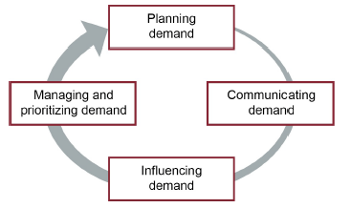 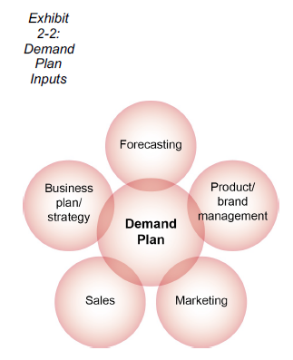

A best practice is to produce a demand plan that has at least an 18-month planning horizon and to revise it

by replanning on a regular basis. An 18-month minimum horizon has other advantages:

* It ensures that each period’s demand has been planned and reviewed multiple times, with increasing accuracy each time.
* Planned product and brand management and marketing activities typically span at least an 18-month horizon, and sales activities typically span at least a 12-month horizon, so the most current and reliable information on internal plans and likely actions of customers and competitors falls within this 18-month range.
* If the demand plan does not seem to be capable of achieving the goals in the business plan and strategy, a longer horizon allows organizations time to plan and execute additional activities to meet the revenue goals.
* If the demand plan shows a need to increase capacity, it gives the organization sufficient time to approve and execute capital expenditures.
* By midyear the demand plan will show the next year’s projected demand and can be used as a key input to the annual business plan.

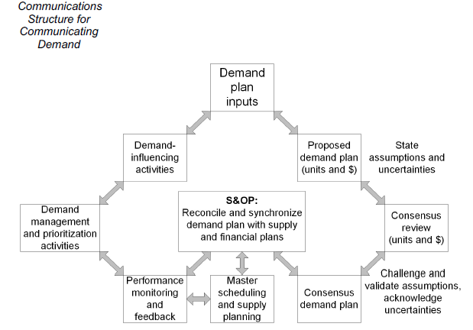

Demand manager is an organizational position that is responsible for:

* Gathering information on demand volume and timing by product, product family, & customer segment
* Performing analytical work on the data and the demand plan
* Building consensus on a demand plan
* Communicating demand information to and from the various stakeholders involved in input, planning, execution, monitoring, and revision of the demand plan. The demand manager may also play a lead role in the S&OP process, for example, by creating various scenarios of demand for supply and finance in an effort to tie the demand plan to the business goals.

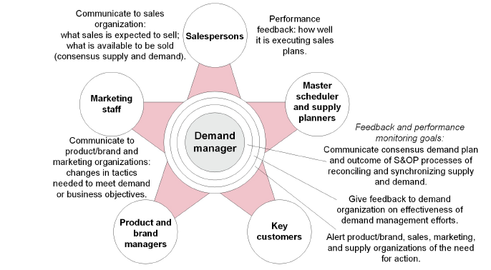

The following elements are important to include in demand dashboards for demand consensus review:

* Historical demand data for the past three months or more, with relevant key performance indicators & metrics for each month
* Demand plan for the next 18 months or more (For each month, this shows the demand plan [actual request for product] and, for comparison, the demand that is necessary to achieve the goals in the organization’s business plan.)
* Prior demand plan (Since plans are revised each month, the prior demand plan can be shown as a point of reference and reasons for significant changes can be discussed.)
* Assumptions made in demand numbers and pricing assumptions
* Planned branding, marketing, and sales promotions activities
* Key risks, opportunities, economic trends, and competitor actions
* Subtleties and uncertainties
* Events and issues of note and decisions that were made

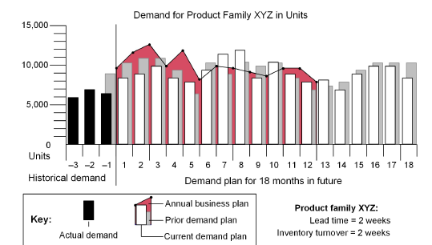

Influencing Demand

Plan-Do-Check-Action Model (PDCA) model is used to:

1. (Plan) to effect improvement
2. (Do) Execute the plan, preferably on a small scale
3. (Check) Monitor the impact, effects of the plan
4. (Act) Results are studied to determine what was learnt & what can be predicted

Demand Management can link different components by using powerful business tools such as collaborative planning, forecasting, and replenishment (CPFR), distributor integration (DI), quick-response programs (QRP), continuous replenishment (CR), and vendor-managed inventory (VMI).

4 organizational strategies that focus primarily on 1 of the 4 components of demand management:

1. Planning demand (fixed high capacity strategy)  
   Try to meet maximum demand as possible & peak demand at any point, assuming capacity is not a bottleneck. Ensuring that capacity will be available will require a focus on planning demand, especially in long term planning. This strategy is used when cost of increasing capacity is much lower than losing demand
2. Communicating demand (highly variable capacity strategy)  
   Matching supply to demand as closely as possible by assuming that capacity is flexible enough to increase or decrease. Matching supplies requires a strong focus on being proactive rather than reactive. It requires a great deal of outsourcing, contract manufacturing, etc.
3. Influencing demand (moderately variable capacity strategy)  
   Involves levelling production & carefully managing demand to meet optimal capacity. This is also called demand shaping, where it involves convincing customers to buy certain models based on excess inventory. Demand is influenced by carefully scheduling delivery of products & services (eg: offering discounts to longer leadtimes) & timing promotions to meet the strategy.
4. Managing & prioritizing demand (fixed average capacity strategy)  
   Involves carefully managing demand by promotions, sales, queues & rationing. By definition, it means insufficient supply. Strategy could be beneficial in cases where focus is on retention on expensive personnel & resources. Eg: An airlines where promotions & discounts are provided to early bookings rather than last minute bookings.

Collaborative planning, forecasting, and replenishment (CPFR) is a way to integrate the components of demand management among supply chain partners. It is a collaboration process whereby supply chain trading partners can jointly plan key supply chain activities from production and delivery of raw materials to production and delivery of final products to end customers. Collaboration encompasses business planning, sales forecasting, and all operations required to replenish raw materials and finished goods. A process philosophy for facilitating collaborative communications.

The idea is to formalize collaborative tasks while reducing redundant work by specifying what work is best done by each supply chain partner. For example, market planning is the responsibility of the manufacturer, while the retailer takes care of category management.

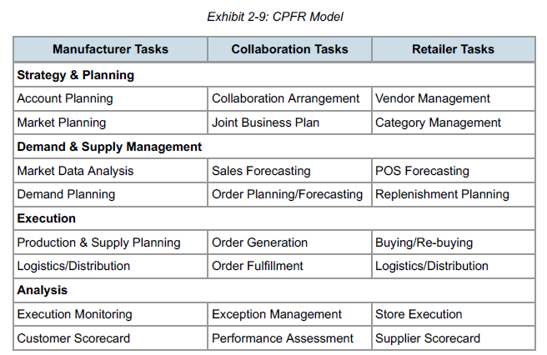

**quick-response program (QRP),** is a system of linking final retail sales with production and shipping schedules back through the chain of supply; employs point-of-sale scanning and electronic data interchange and may use direct shipment from a factory to a retailer.

In a VMI arrangement, the supplier takes over multiple inventory functions. For instance, the supplier may do all or some of the following:

* Determine how the inventory will be stored and displayed.
* Provide the bins, vending machines, or other storage units.
* Replenish the inventory on a schedule it determines based on POS data.
* Maintain inventory records.
* Handle the delivery, receiving, stocking, and counting functions.
* Provide a permanent vendor representative at the customer’s premises to perform the resupply and reorder functions (e.g., automotive plant).

In VMI strategy, organizations have adopted a VMI-consignment model where supplier continues to own the inventory as well as manage it. Consignment in terms of Inventory is defined as the process of a supplier placing goods at a customer location without receiving payment until after the goods are used or sold. Consignment is also sometimes called as VOI (Vendor Owned Inventory)

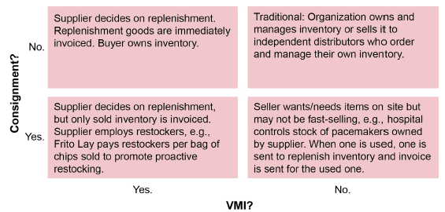

The metrics for tracking the success of a VMI relationship should reflect its potential

benefit to both parties, not just one. Some customers develop VMI supplier certifications. Specifically, the

partners should track the following measures of success:

* Reduction or elimination of the bullwhip effect
* Reduced inventory costs in the supply network as a whole
* Reduction or elimination of stockouts or spoiled product on shelves
* Reduction of lead times for deliveries and more on-time deliveries
* Increased inventory turns

Forecasting principles:

* Forecasts are almost always wrong
* Forecasts should include an estimate of error
* Forecasts are more accurate for groups rather than single items
* Forecasts are more accurate for near term than long term demands

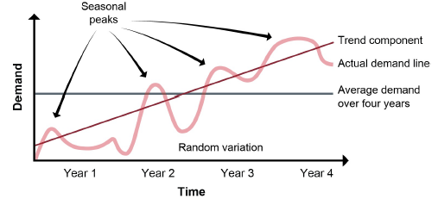

**Random variation** is “a fluctuation in data that is caused by uncertain or random occurrences” Random variation is what is left after seasonality is removed. It is the unpredictable part of a data series that cannot be explained by the other factors

Forecasting Methods

1. Qualitative Methods  
   One way to mitigate bias is to ask estimators to provide a pessimistic estimate, a most likely estimate, and an optimistic estimate



* 1. Judgmental/expert judgment
  2. Delphi method  
     surveying experts and collating their responses into a document that keeps the responses anonymous. The compiler continues to work toward consensus in successive rounds by highlighting areas where there is disagreement and allowing responders to change their responses after reading the current group opinion.
* Quantitative Methods (time-series forecasting)
  1. Time Series
     1. Simple Moving Average
     2. Weighted Moving Average
     3. Exponential Smoothing
  2. Associative

Steps in Time Series Forecasting:

1. Visualizing
2. De-Seasonalizing  
   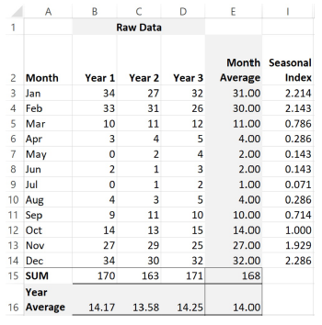  
   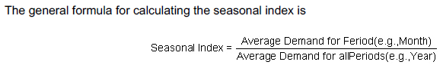  
   Deseasonalizing data involves dividing the raw data by the seasonal index for the given month.  
   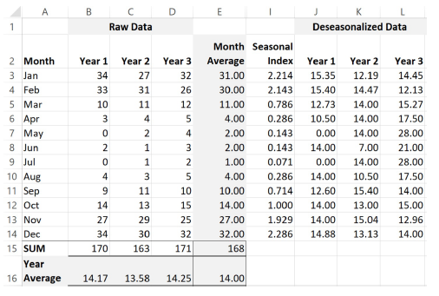
3. Reseasonalizing

The **simple moving average** is the average of demand from several preceding periods. Three- and six-month periods are commonly used.

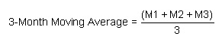

The simple moving average can be useful when demand is relatively constant from period to period. The method can be used to prevent an overreaction to a random or irregular spike or dip in a given month because it smooths out these variations

The **weighted moving average** (or weighted average) forecasting method places weights on the periods being averaged, usually to put greater emphasis on the more recent periods and relatively less emphasis on the more distant periods.



**Exponential smoothing** uses three inputs in its equation: the last period’s forecast, the last period’s demand, and a smoothing constant, a number greater than 0 and less than 1 represented by alpha (α),



A constant of 0.3, would put 30 percent of the weight on the last period’s demand and 70 percent on the last period’s forecast. This constant smooths out random or irregular spikes or dips in actual demand by placing more weight on the prior forecast. Most organizations select a smoothing constant between 0.05 and 0.5. A constant of 0.05 would give minimal weight to the preceding period’s actual demand, while 0.5 would equally weight the actual and forecast results. The constant value is selected by experience, trial and error, and testing against historical data.

Note, however, how the forecast quickly becomes repetitive; after a few periods, everything is based on

forecast data and an average or weighted average of the same three numbers results in the same number.

Therefore, these methods are less useful the further out into the future you go.

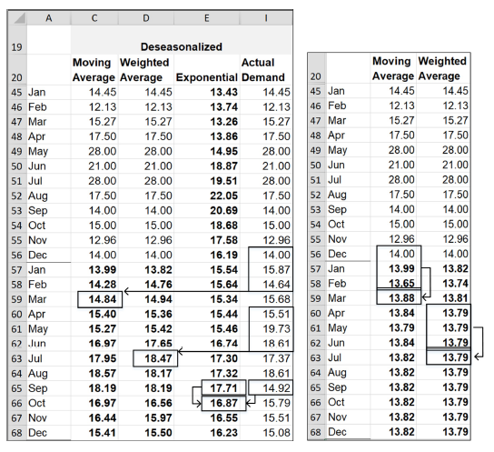



Reseasonalizing

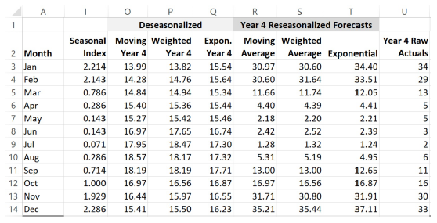

When trends vary too much for these time-series methods to be useful in predicting, associative forecasting can be used.

Associative forecasting (also called causal, correlation, explanatory, or extrinsic forecasting) uses data

gathered from one or more internal or external sources as a predictor of something that is presumed to be

correlated. The predictor is called the independent variable. The element being predicted is called the

dependent variable.

Correlation is an observation that the change in an independent variable has a measurable effect on a

dependent variable. However, just because the effect can be reliably observed over time does not mean that

the one thing caused the other thing. It could be that some third force is affecting both of them, or the

correlation could be a coincidence that would be proven incorrect after a longer period of study.

a **leading indicator** is a specific business activity index that indicates future trends. **Lagging indicators** are the economic and financial factors that reflect the changes that have already occurred in the economy.

Simple regression (also called linear regression) uses a formula to make an association between the

dependent variable y (the element being predicted) and the independent variable x (the predictor), with two

other elements, alpha and beta. Beta (β) is the slope, which is a value used as a multiplier to find the correct

placement of the forecast result. Alpha (α) is the intercept.



strength of correlation is called the coefficient of correlation (r), if value =1, then it is a perfect positive correlation, value =-1, then it is a perfect negative correlation, if value = 0, then no correlation at all

Multiple regression is an extension of simple regression; there are multiple predictive variables rather than

just one.

How to track Forecast Error:

1. Mean Absolute Deviation
2. Tracking Signal
3. Standard Deviation
4. Mean Squared Error
5. Mean Absolute Percentage Error





Bias is “a consistent deviation from the mean in one direction (high or low). A normal property of a good forecast is that it is not biased”, calculated by Cumulative Forecast Error:



the average of the absolute values of the deviations of observed values from some expected value. It can be calculated based on observations and the arithmetic mean of those observations.

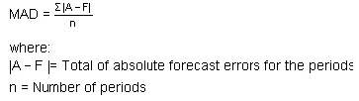

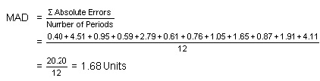

A MAD of 1.68 units implies that forecasts are off on average for the review period by about plus or minus 1.68 units.

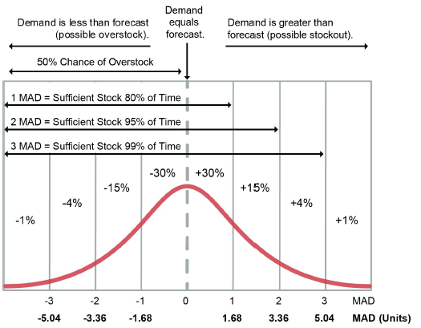

So, to cover for 98% service levels, 2.56 MAD safety stock is needed



the tracking signal is “the ratio of the cumulative algebraic sum of the deviations between the forecasts and the actual values to the mean absolute deviation

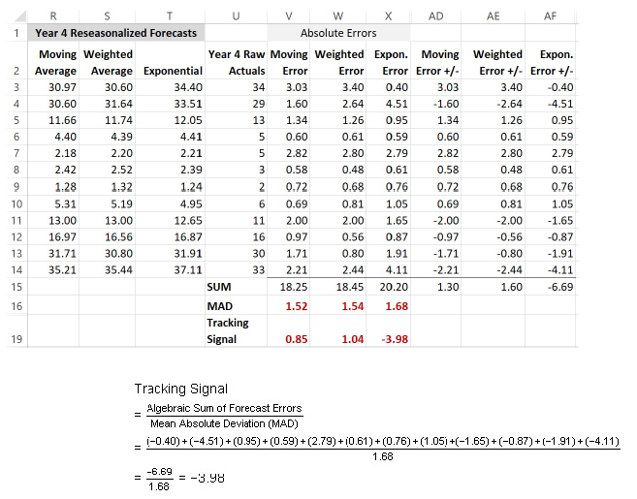

Tracking Signal helps in 2 ways:

* **Forecast bias.** If the tracking signal is continually negative, we are consistently over-forecasting. If it is consistently positive, we are under-forecasting. Ideally, the tracking signal should oscillate between positive and negative values. If not, it should be the first thing to work to eliminate.
* **Suitability of the forecasting method.** If the tracking signal remains in a range of +4 to −4, then, as a rule of thumb, the method being used to forecast that SKU should be considered to be working correctly

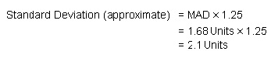

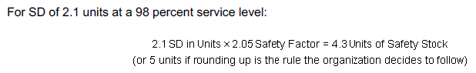

Which means units of ss remain unchanged (4.3 units) whether you calculate it via MAD or SD (which is approx. 1.25x of MAD)

the mean squared error (MSE), magnifies the errors by squaring each one before adding them up and dividing by the number of forecast periods.



There is a drawback to the MAD calculation in that it is an absolute number that is not meaningful unless

compared to the forecast. Mean absolute percentage error (MAPE) is a useful variant of the MAD calculation

because it shows the ratio, or percentage, of the absolute errors to the actual demand for a given number of

periods.



**projected available balance** (PAB) is “an inventory balance projected into the future”. Whenever the PAB in a given period falls to a negative value or below the safety stock level, the master production schedule (MPS) must be reevaluated.

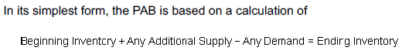

For the MPS, this is complicated by having a formula for the periods before the demand time fence and

another for after the demand time fence.

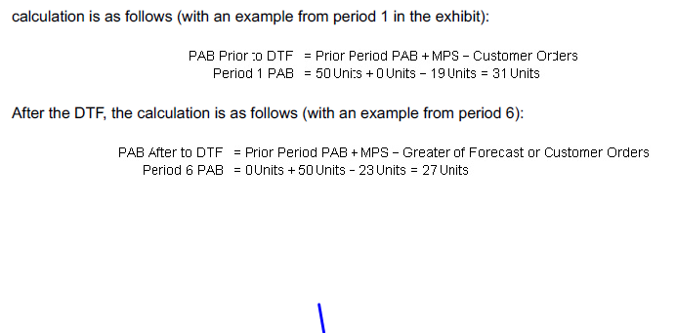

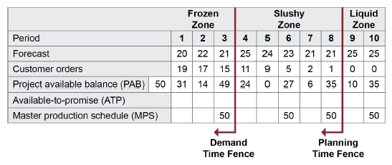

As you can see, prior to the DTF we are concerned only with the known component of demand (customer

orders). After the DTF it is the greater of forecast or orders. Because, in the frozen zone, materials are committed to orders and orders are frozen. The MPS logic therefore considers that only orders we have in hand will consume the on-hand inventory. Beyond the DTF, we can expect to receive more orders than those already booked.

Using the PAB formula, the first period that goes negative is period 3. (The calculation would result in –1 units in period 3 if no MPS activity had been proposed.) Therefore, production of 50 units (recall that the replenishment for this product is fixed at 50 units) is required in period 3.

available-to-promise (ATP) is defined as “the uncommitted portion of a company’s inventory and planned production maintained in the master schedule to support customer order promising.” **order promising** as “the process of making a delivery commitment (i.e., answering the question ‘When can you ship?’).”

The methods used to compute ATP are:

* discrete ATP (or noncumulative) - used for products that have an expiration date
* cumulative ATP with look-ahead
* cumulative ATP without look-ahead

ATP for the first period of the planning horizon is calculated as follows (with an example from period 1 of the exhibit):



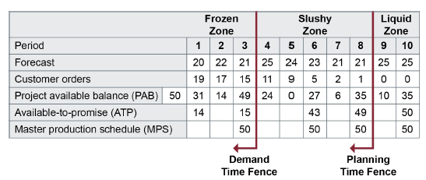

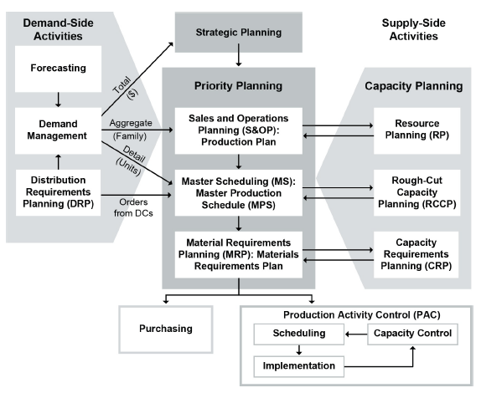

Demand history data are gathered and cleansed. A statistical forecast is run and analyzed for events or

outliers that are not expected to repeat in the future.

The statistical forecast with associated errors is reviewed with the product and brand management,

marketing, and sales teams. The teams add information to the demand plan that will improve forecast

accuracy.

The demand plan is finalized with the demand-side teams and passed on to supply.

The supply team reviews the demand plan and constrains it based on capacity availability.

Both supply and demand review the constrained plan with the finance team and executive

management.

When the executive S&OP meeting is held, the result is the communication of a single plan: Sales sells

to the plan and supply produces to the plan.

One of the outputs of S&OP is the production plan, which provides the rate of production at the family

level. Resource requirements are evaluated with the resource plan.

The production plan is the input to master scheduling, and its output is the master production schedule

(MPS). The MPS is typically a weekly plan at the item level with an evaluation of capacity through

rough-cut capacity planning.

Then material requirements planning uses bill-of-material data, inventory data, and the MPS to

calculate requirements for materials, resulting in planned production and purchase orders.

Production activity control receives the output of material requirements planning and detail planning, and final assembly scheduling is done.

The process brings together all the plans for the business (sales, marketing, development, manufacturing, sourcing,

and financial) into one integrated set of plans. It is performed at least once a month and is reviewed by management at an aggregate (product family) level. The process must reconcile all supply, demand, and new-product plans at both the detail and aggregate levels and tie to the business plan.

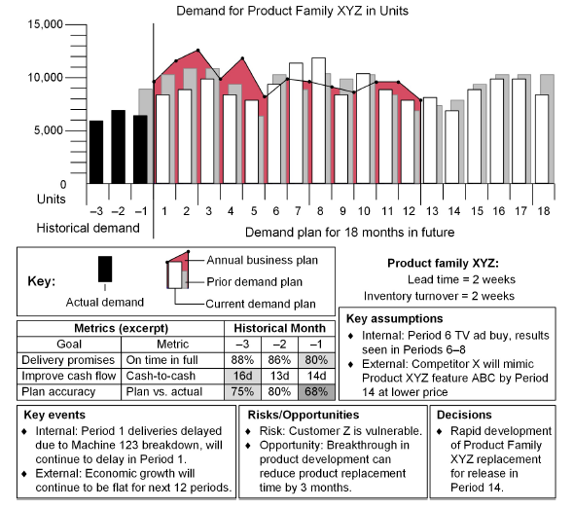

Most supply chains operate with between 14 and 25 individual demand forecasts. Those that do use a single set

of demand numbers typically have adopted the S&OP process.

If supply cannot match demand in total units or in product mix, then the

meeting involves generating one or more alternative plans that propose solutions to the supply and demand

mismatch, such as the following:

* Produce above demand for certain periods to meet later spikes in demand.
* Increase capacity by hiring, adding shifts, planning overtime, leasing new equipment, or outsourcing (or proposing the opposite to reduce capacity).
* Reduce the demand plan (as a last resort).

**Backlog** definedas “all the customer orders received but not yet shipped; sometimes referred to as open orders or the order board.”

A **level production strategy** or **method,** or **level strategy,** aims for the same output in each period

(e.g., each month). Itis “a production planning method that maintains a stable production rate while varying inventory levels to meet demand.” a **chase production method** as “a production planning method that maintains a stable inventory level while varying production to meet demand.” A **hybrid strategy** combines elements of level and chase production. The plant runs near full capacity for part of the cycle, allowing inventory to build up, & then slows or shuts down to allow the inventory to shrink as customers buy the product

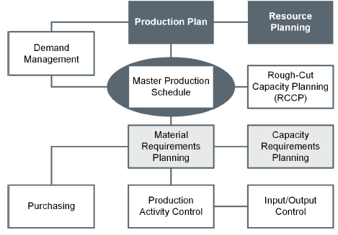

**Master Scheduling** is a schedule format that includes time periods (dates), the forecast, customer orders, projected available balance, available-to-promise, and the master production schedule. It takes into account the forecast;

the production plan; and other important considerations such as backlog, availability of material, availability of capacity, and management policies and goals.

S&OP works only with aggregate supply and demand, projecting volumes for product families rather than individual products. The master scheduling process, therefore, has to disaggregate the product family data into numbers of individual products based on inventory levels, forecasts, demand plans, order backlogs, and other considerations used to decide what you need to produce and how much of each item to produce.

MPS also takes into account **interplant demand,** a “plant’s need for a part or product that is produced by

another plant or division within the same organization”

There are three stages in the MPS development process:

1. First draft of the plan

2. Rough-cut capacity planning to verify that the production targets are feasible

3. Revisions to the plan by the master scheduler or revisions to available capacity if capacity isn’t sufficient to meet the targets or greatly exceeds expected load

Raw materials and components are planned using material requirements planning (MRP), and inventory levels at specific locations are planned using distribution requirements planning (DRP).

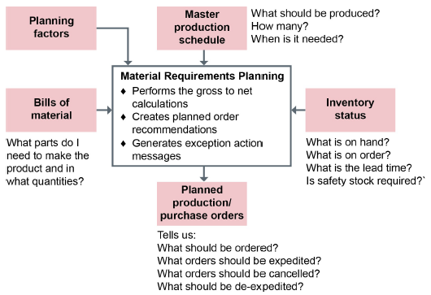

**Firm planned orders (FPOs)** are planned order[s] that can be frozen in quantity and time. The computer is not allowed to change [them] automatically; this is the responsibility of the planner in charge of the item that is being planned.

An **open order** (released order) is “a released manufacturing order or purchase order.”

A **scheduled receipt** is “an open order that has an assigned due date.”

**MRP Outputs:**

**Planned order receipts.** A planned order receipt (planned receipt) is “the quantity planned to be received at a future date as a result of a planned order release. Planned order receipts differ from scheduled receipts in that they have not been released.”

**Planned order releases.** A planned order release is “a row on an MRP table that is derived from planned order receipts by taking the planned receipt quantity and offsetting to the left by the appropriate lead time.” Planned order releases may differ depending on whether the order needs to be manufactured or purchased.

An **exception report.** This is “a report that lists or flags only those items that deviate from the plan.”

When the planning system calculates net requirements in MRP, it generates a set of planned orders, which are subject to change until orders are either made into firm planned orders (FPOs) by the planner or are released to become open orders or scheduled receipts (if assigned a due date).

Note that when a family of related items is released as if it were one item, it is considered a joint replenishment system. **joint replenishment** is a process of coordinating the lot sizing and order release decision for related items and treating them as a family of items. The objective is to achieve lower costs because of ordering, setup, shipping, and quantity discount economies.

The router (or routing file) maps the journey of a component from work center to work center, specifying all the operations it undergoes on the way to completion. It indicates each of the manufacturing steps required, the sequence of the steps, and the time required. There will be one entry for each operation. This can be a very simple matter if manufacturing takes place in one plant, only a few operations are involved, and the work centers are near one another. It can be a very complex map if the component travels around a global supply network with numerous partners.

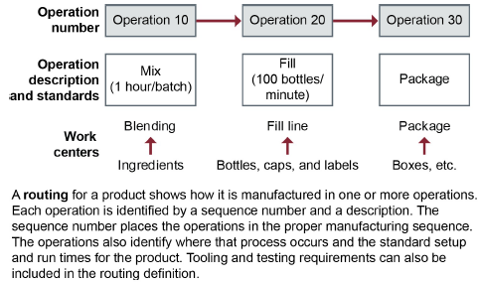

Lot-for-Lot technique also called as Fixed Order Quantity (FOQ)

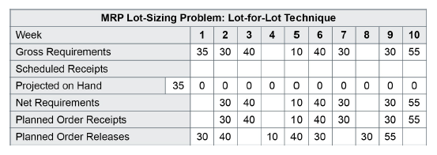

Component Orders are Offset by Leadtimes for Simultaneous Arrival

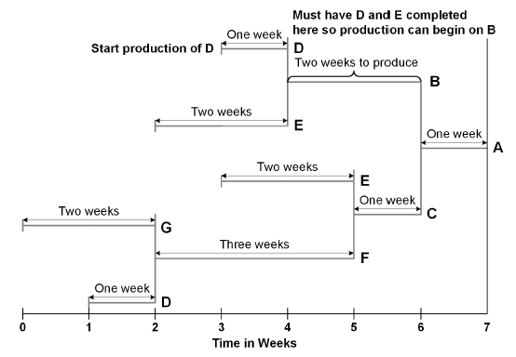

**pegging is defined** as follows: In MRP and MPS, the capability to identify for a given item the sources of its gross requirements and/or allocations. Pegging can be thought of as active where-used information.

A refinement of basic MRP software is called **closed-loop MRP**, because it incorporates feedback on

available capacity (instead of infinite capacity). It calculates the impact of each order on the work center that is scheduled to complete the order, and, if it finds too little capacity at that center, it may change the order date. Other options are to send the order to another work center or site or outsource it.

**MRP II** is a method for the effective planning of all resources of a manufacturing company. Ideally, it addresses

operational planning in units, financial planning in dollars, and has a simulation capability to answer what-if questions.

MRP II incorporates the following more-advanced functions not available in previous MRP programs:

* It includes financials—a separate functional area from manufacturing.
* It provides visibility of material and capacity requirements defined in an operations plan.
* It provides detailed activity information and translates activities to financial statements.
* It suggests ways to bring activities back into line with planned priorities.
* It integrates long-term planning (business planning and methodologies that have evolved to become S&OP) with operational planning.

Distribution requirements planning (DRP) organizes inventory requirements so the organization has time to plan for when and how many goods will be required; **DRP** is “the function of determining the need to replenish inventory at branch warehouses”

There are three particular drawbacks to the pull system:

* Orders are likely to increase as they travel up the chain (the bullwhip effect).
* The company doing the ordering knows nothing about the needs and plans of the other chain partners, who may have a greater need for the stock to meet customer service goals.
* The order doesn’t take into account the supplier’s situation.

Hybrid systems are push-pull systems in which push distribution is pursued through centralized planning

down to a particular supply chain level or echelon but pull distribution through decentralized planning is used

after this point. For example, centralized planning could use information on demand from the retail end of the

chain, aggregate this demand at the regional distribution centers (DCs), and push inventory to these DCs.

The customers of these DCs, perhaps wholesalers and retailers, then order inventory from these DCs as

they see fit.

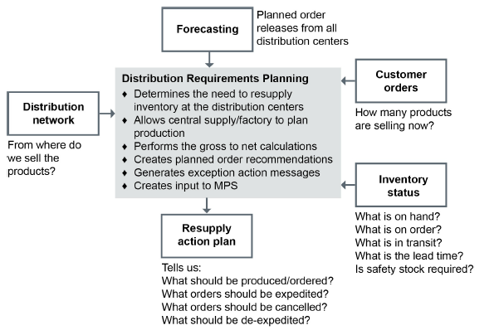

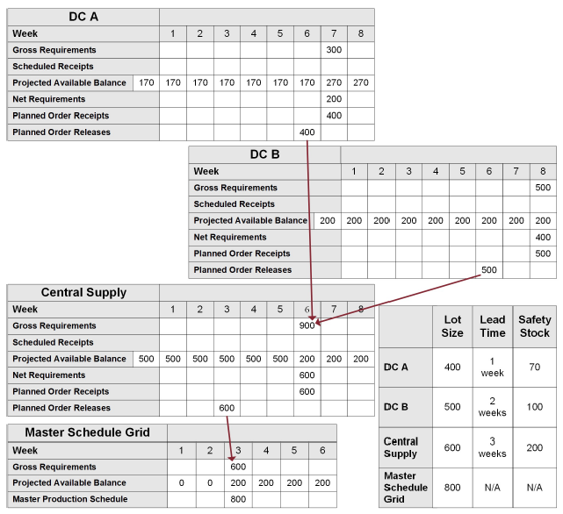

**Capacity management** is the function of establishing, measuring, monitoring, and adjusting limits or levels of capacity in order to execute all manufacturing schedules (i.e., the production plan, master production schedule, material requirements plan, and dispatch list). Capacity management is executed at four levels:

* Resource planning
* Rough-cut capacity planning
* Capacity requirements planning
* Input/output control

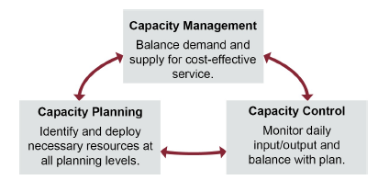

**capacity planning** is the process of determining the amount of capacity required to produce in the future. This process may be performed at an aggregate or product-line level (resource requirements planning), at the master scheduling level (rough-cut capacity planning), and at the material requirements planning level (capacity requirements planning).

**capacity control** is the process of measuring production output and comparing it with the capacity plan, determining if

the variance exceeds pre-established limits, and taking corrective action to get back on plan if the limits are exceeded.

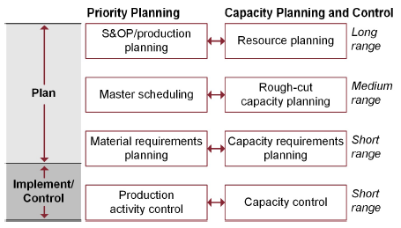

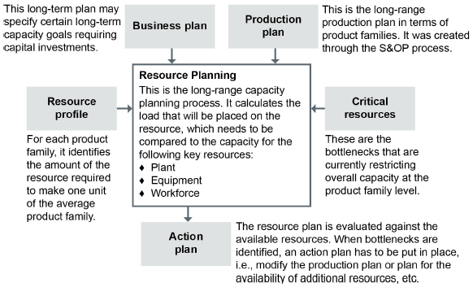

a **resource profile** is the standard hours of load placed on a resource by time period. Production lead-time data are taken into account to provide time-phased projections of the capacity requirements for individual production facilities.

Ways to stage growth in capacity:

* One-step lead strategy: expanding all at once ahead of demand
* Stepwise lead strategy: expanding in steps ahead of demand
* Stepwise lag strategy: expanding in steps behind demand (to catch up, in other words)
* Stepwise overlapping strategy: expanding in steps that are sometimes ahead of and sometimes behind forecast demand

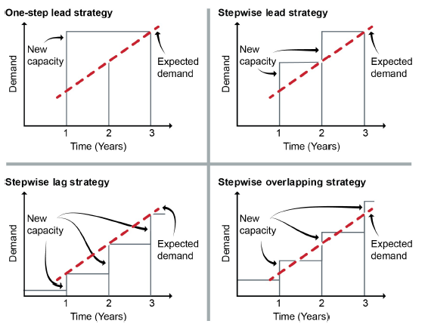

**Rough-cut capacity planning (RCCP)** is defined as the process of converting the master production schedule into requirements for key resources, often including labor; machinery; warehouse space; suppliers’ capabilities; and, in some cases, money.

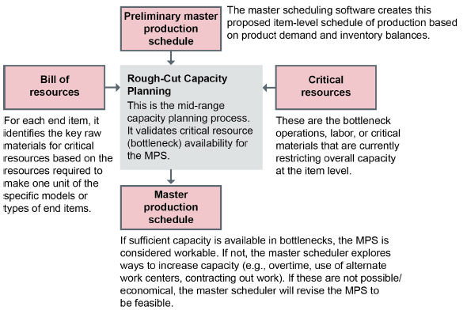

The output of the RCCP process is a workable master production schedule. An MPS is considered workable

if the master scheduler has verified that:

* Bottleneck capacity per item per time period is sufficient
* The plan makes the best use of resources
* Customer delivery promises can be kept
* The plan is still economical given all excess costs that will be incurred, such as overtime.

Capacity requirements planning (CRP) determines in detail the amount of labor and machinery required to

carry out production tasks specified in the MRP, translating MRP orders (measured in units) into hours of

work for each work center in each time period. One more purpose of capacity requirements planning is to assign each facility, work center, and operation a load and perform load leveling.

**Load leveling:** Spreading orders out in time or rescheduling operations so that the amount of work to be done in sequential time periods tends to be distributed evenly and is achievable. Although both material and labor are ideally level loaded, specific businesses and industries may load to one or the other exclusively (e.g., service industries)

**manufacturing lead time** (production lead time) is the total time required to manufacture an item, exclusive of lower level purchasing lead time. For make-to-order products, it is the length of time between the release of an order to the production process and shipment to the final customer. For make-to-stock products, it is the length of time between the release of an order to the production process and receipt into inventory. Included here are order preparation time, queue time, setup time, run time, move time, inspection time, and put-away time.

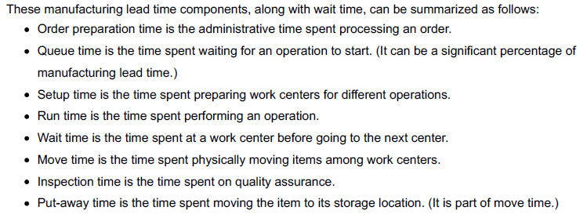

**Steps of CRP**

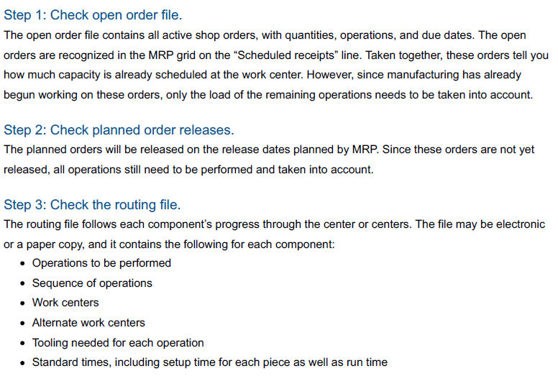

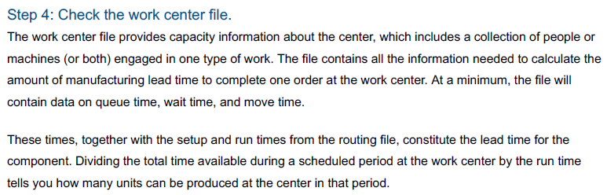

Capacity control is the level of capacity planning that has the shortest horizon and takes place closest to the daily action of manufacturing. This is where the planned activities get carried out. Production activity control (PAC), of

which capacity control is one part, consists of all those activities meant to ensure that everything goes according to plan. PAC has 4 main objectives:

* Execute the master production schedule and the material requirements plan.
* Make the best use of resources.
* Minimize work-in-process (WIP).
* Maintain customer service.

Efficiency is the ratio of the actual output to the standard output expected.

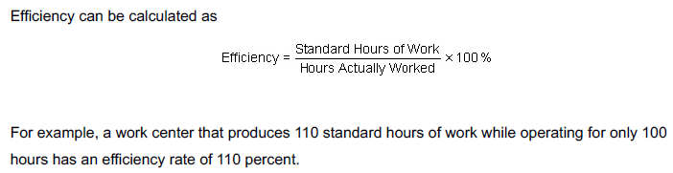

For example, a work center that produces 110 standard hours of work while operating for only 100

hours has an efficiency rate of 110 percent



**Demonstrated Capacity** is simply the average output (Rated Capacity) measured over a period of time.

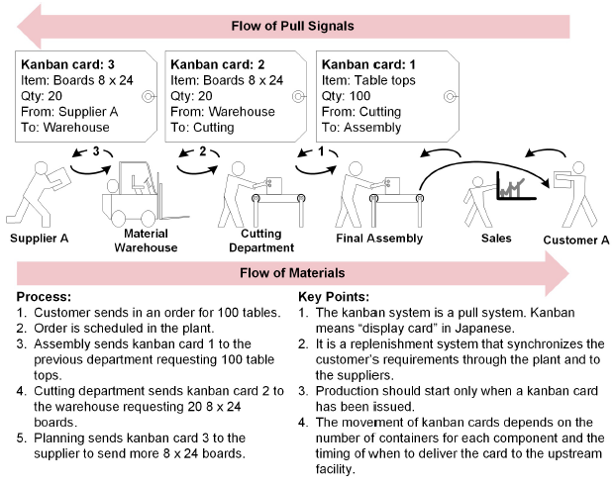

Developing lean thinking focuses on taking only the absolute minimum numbers of steps (literally as well as

figuratively) and using only the bare minimum of resources. A simple example: Reduce the distance between

work centers with the heaviest traffic. Fewer steps taken by many employees can add up to considerable

savings of time, energy, and money. (Organizing the entire work site this way is called JIT layout.) Produce

only what customer satisfaction requires. Quality is in the eyes of the customer. Reduce waste, reuse, and

recycle.

**Decoupling** is defined as creating independence between supply and use of material. Commonly denotes providing

inventory between operations so that fluctuations in the production rate of the supplying operation do not constrain production or use rates of the next operation.

ABC Analysis of Inventory:

* A contributing to 80% value but residing in 20% SKUs
* B contributing to 15% value but residing in 30% SKUs
* C contributing to 5% value but residing in 50% SKUs

**Inventory Costs**

**Acquisition cost** is “the cost required to obtain one or more units of an item. It is order quantity times unit cost.” Acquisition cost is also referred to as product cost or purchase price.

**Carrying cost** (also called holding cost) is “a percentage of the dollar value of inventory per unit of time

(generally one year)” .It is a variable cost that increases as the level of inventory increases. Carrying costs may be as high as 40 percent of the value of the inventory and are unlikely to be less than 15 percent.

**ordering costs** is Used in calculating order quantities, the costs that increase as the number of orders placed increases. It includes costs related to the clerical work of preparing, releasing, monitoring, and receiving orders, the

physical handling of goods, inspections, and setup costs, as applicable.

Ordering costs are all those costs that do not vary due to quantities ordered but vary only by the frequency of

ordering.

A **backorder** (also known as a stockout) is “an unfilled customer order or commitment…an immediate (or past due) demand against an item whose inventory is insufficient to satisfy the demand”. The cost of backorders, lost sales, and lost customers can be difficult to quantify financially but can be measured using various means such as percentage of orders shipped on schedule, which can help quantify the safety stock investment needed for a particular item at a particular location to keep this risk at acceptable levels.



Inventory is a current asset that is broken down in this example by raw materials, work-in-process inventory, and finished goods inventory.

**Inventory as an asset**

Raw materials, WIP, and finished goods are carried as current assets on the balance sheet. MRO inventory

is a period expense; it is expensed on the income statement during the period in which it is purchased. The

balance sheet items do not impact the income statement until the inventory is sold, reduced to fair market

value, or written off (when inventory becomes obsolete).

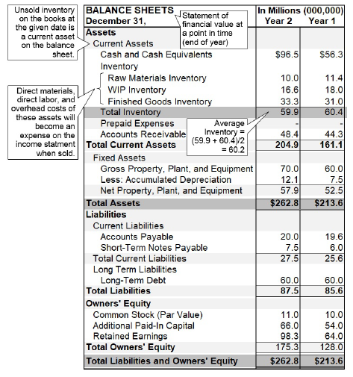

Optimum inventory holdings are those that equal projected sales in the organization’s demand plan (plus an optimal amount of safety stock), because inventory that is projected to be sold soon is considered more liquid, while inventory in excess of the demand plan is less liquid.

COGS includes inventory costs of direct labor, direct materials, and factory overhead for all goods that sold that year. Reducing elements in COGS can therefore directly increase gross profit.

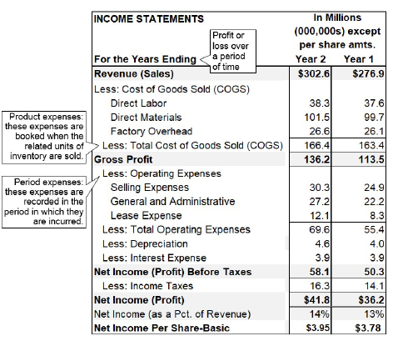

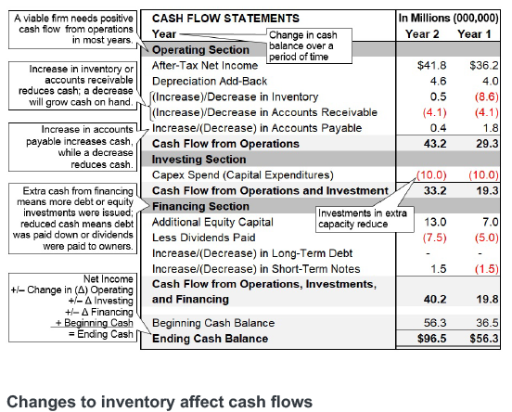

Inventory can strongly affect cash flows, which, in turn, can affect covenants with lenders (contractual

agreements that may include lender requirements that the borrower maintain certain financial ratios at

certain levels). Even a reduction in inventory can create one-time adjustments for finance that impact

reporting. However, once the adjustments are made, the long-term financial impact of inventory reductions is

usually positive.

The supply chain manager learns the value of consulting with finance prior to making suggestions for a major change in inventory so that finance can determine ways to accommodate the change while keeping the company solvent. The financial officer recommends that to prevent such a situation from recurring that the organization should make financial reservations for aging or obsolete stock, which would help the finance department understand how to prepare for the inventory write-off.

In addition to buffering, consolidation, and break-bulking, storage locations can provide three other benefits:

* Sorting (cross-docking, assembly, and mixing)
* Seasonal storage (produce inventory year-round; sell in one season)
* Reverse logistics (sites for returns, remanufacturing, repair, remarketing, and disposal or recycling)

Economic order quantity (EOQ)

Economic order quantity (EOQ) is a more sophisticated form of FOQ that is widely used. EOQ involves cost

calculations—to determine the most cost-effective number of items to order when replenishing inventory using a fixed order quantity model. In short, the EOQ is the order size that gives you the lowest total cost for carrying and ordering (or setup) costs

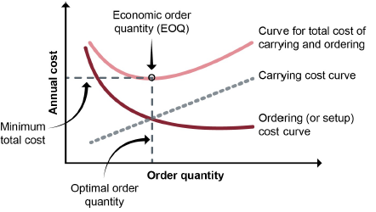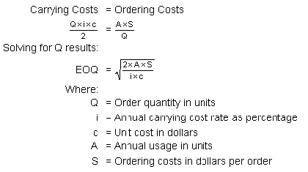

* The total costs tend to drop until they reach a minimum, and then they start rising again. So there is an incentive to increase order quantity—but only to a point. And there is a disincentive to order too much, although the more you order, including safety stock, the more assurance you have that you can provide a high level of customer service.
* The minimum total cost occurs where carrying and ordering costs are equal—where the cost lines intersect. After that point of equality, carrying costs tend to rise more rapidly than ordering costs decline. Because of the relationship of the cost curves, you can reduce total costs by reducing ordering costs, which is a goal of lean manufacturing.

It depends upon the following set of assumptions:

* Demand is constant and known.
* Lead time is constant and known. (The same amount of time always elapses between the time you place the order and the time it arrives.)
* The items ordered arrive all at once, not in stages.
* There are no quantity discounts.
* The variable costs in the calculation model are limited to carrying costs and ordering costs (whereas in reality other variable costs exist).
* There will be no stockouts if you place orders on schedule.

**When to Order Replenishment?**

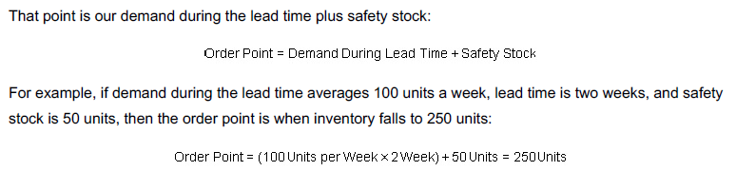

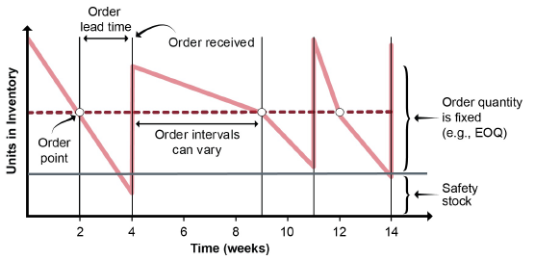

In a periodic review system, order intervals are fixed, such as each week, month, or quarter, and order

quantities (shown as Q1, Q2, and Q3) are allowed to vary. The warehouse determines a base stock level, or maximum level of inventory, as shown in the exhibit. The base stock is the inventory target, or “order-up-to” level. This is the level of inventory necessary to maintain effective and continuous operations. The inventory position is reviewed in each period, and the warehouse orders enough to raise the inventory position to the base stock (target) level.

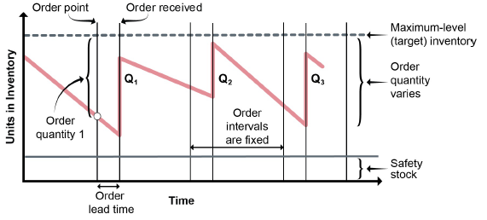

The quantity in stock plus the quantity ordered must be enough to prevent stockouts, which means non–

safety stock inventory has to last until the next review period plus the lead time required for the next shipment. The quantity ordered is the maximum amount less the quantity of inventory on hand at the order period:

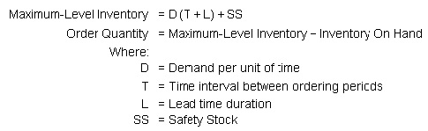

For example, if average demand is 50 units per week and there are 5 working days, demand per day is 10

units/day. Assume that orders are placed every 10 working days and lead time duration is 3 days. If safety

stock should be 4 days’ supply, at 10/units per day this would be 40 units. If there are 42 units on hand at the

order point, then the maximum-level inventory and order quantity are calculated as follows:

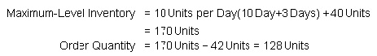

Min-max system

With a min-max system, both order timing and order amount are allowed to vary. Orders are submitted after

inventory has fallen below the minimum point, but inventory isn’t allowed to go over a maximum

**time-phased order point (TPOP)** system is MRP-like time planning logic for independent demand items, where gross requirements come from a forecast, not via explosion. This technique can be used to plan distribution center inventories as well as to plan for service (repair) parts, because MRP logic can readily handle items with dependent demand, independent demand, or a combination of both. Time-phased order point is an approach that uses time

periods, thus allowing for lumpy withdrawals instead of average demand. When used in distribution environments, the planned order releases are input to the master schedule dependent demands.

Demand-driven material requirements planning system

Demand-driven material requirements planning (DDMRP) is a relatively new type of ordering system that can

be used for dependent and independent demand items at any point in the supply chain. DDMRP strategically

positions inventory to achieve all the benefits of modern supply chain management (reduce inventory, lead

times to the customer, and the bullwhip effect and increase customer service and asset usage efficiency)

without needing to rely on safety stocks of finished goods or a pure make-to-order environment. Instead,

DDMRP determines how to shrink total lead times by creating buffer inventories of key components that

have longer lead times than other components making up a finished good.

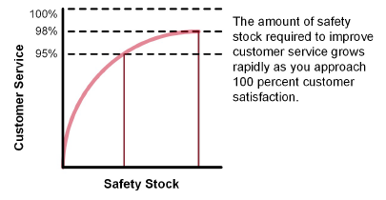

**safety lead time i**s an element of time added to normal lead time to protect against fluctuations in lead time so that an order can be completed before its real need date. When used, the MRP system, in offsetting for lead time, will plan both order release and order completion for earlier dates than it would otherwise.

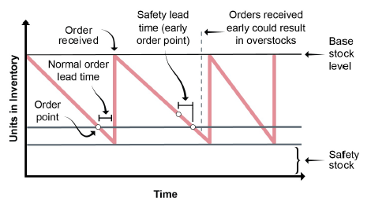

Safety lead times also require performing the same balancing act between ordering too soon and having overstocks and ordering too late and risking stockouts. For example, materials shipped overseas often have

lead times of 60 days or more. Ordering too soon can result in a serious overstock because orders arrive by

the container load. However, delays from weather, labor unrest, or other factors could cause a serious stockout (also due to the large order size). In any case, supply chain managers will—and should—continue looking for ways to achieve the perfect balance between minimal inventory and maximum customer service.

**Inventory shrinkage** is “reductions of actual quantities of items in stock, in process or in transit. The loss may be caused by scrap, theft, deterioration, evaporation, and so forth”

**inventory accuracy** is When the on-hand quantity is within an allowed tolerance of the recorded balance. This important metric usually is measured as the percent of items with inventory levels that fall within tolerance. Target values usually are 95 percent to 99 percent, depending on the value of the item. For logistical operations (location management) purposes, it is sometimes measured as the number of storage locations with errors divided by the total number of storage locations.

**inventory adjustment** is a change made to an inventory record to correct the balance, to bring it in line with actual physical inventory balances. The adjustment either increases or decreases the item record on-hand balance.

There are two general approaches to keeping accurate inventory records, the results of which are used to

make inventory adjustments when errors are found: periodic counts of all items and continuous cycle counts

of specific items. Cycle counting is the state of the art, but periodic counting still has its place.

**Periodic counting.** Periodic counting is the familiar and time-honored way of taking inventory: Shut

down the facility once a year and send a large group of employees or temps into the area to count

every last item and calculate the dollar value of the items on the shelves. It’s disruptive, it’s expensive,

and it’s prone to inaccuracy because of the low expertise of the counters. (They may do it only once a

year, after all.)

**Cycle counting** is defined as an inventory accuracy audit technique where inventory is counted on a cyclic schedule rather than once a year.The key purpose of cycle counting is to identify items in error, thus triggering research, identification, and elimination of the cause of the errors.

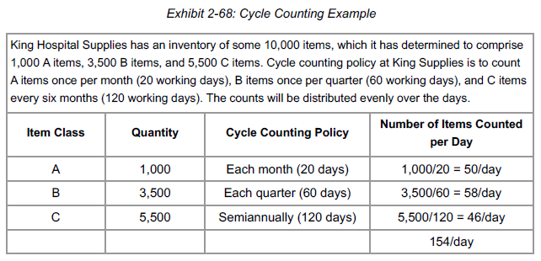

**total cost of ownership (TCO)** In supply chain management, is the total cost of ownership of the supply delivery system is the sum of all the costs associated with every activity of the supply stream. The main insight that TCO offers to the supply chain manager is the understanding that the acquisition cost is often a very small portion of the total cost of ownership.

Landed costs are often the most important costs considered for a TCO study of the supply chain. Some

important landed costs that frequently differ between alternatives are

* Purchase price/production cost
* Transportation cost (at each stage), including special packaging costs
* Customs and related costs (tariffs, duties, taxes, fees for various intermediary services)
* Inventory costs (carrying, ordering, and backorder costs)
* Outsourcing cost
* Monitoring and control costs, which are generally higher when outsourcing is used (e.g., sending employees abroad to manage the relationships).

Some landed costs may or may not differ between the alternatives or may be omitted from consideration to

simplify analysis. Such costs could include

* Financing and opportunity costs
* Sales and marketing
* Administrative (executive, clerical, including billing/payment, and information system)
* Reverse supply chain (returns)
* Insurance and risk management
* Taxes and foreign exchange (relevant for global sourcing decisions).

Process change costs include the costs of evaluating choices and implementing the changes to the supply

chain. These costs are sometimes called pre-transaction costs because they are administrative costs often

incurred before landed (transaction) costs are incurred. Such costs may include

* Requirements identification and research
* Product development
* Contract sourcing (search, selection, qualification, and legal review)
* Process change and training of supplier and organization in each other’s operations
* Plant openings/closings, hiring/layoffs
* Supplier education and integration (including software systems integration).

Ongoing costs (or post-transaction costs) are the costs of ownership that occur throughout the life of the

product or equipment. A durable product will have lower ongoing costs than one that costs less but has lower

quality. Examples include

* Life cycle costs (quality, durability, and maintainability versus price)
* Maintenance, repair, and operations and other ongoing service and repair part costs
* Costs of quality (line fallout, defects, in-house or field repairs, rework, returns, warranties)
* Sustainability costs (recycling, recovery of materials, etc.)
* Reputation costs (customer loyalty versus lost customers).

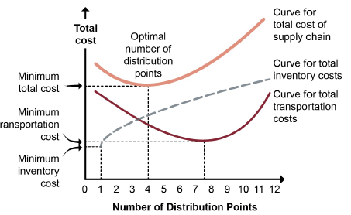

**Choosing activities to contract out**

Is the activity a core competency?

What are the consequences of losing related skills or knowledge?

What is the landed cost (or total cost of ownership)?

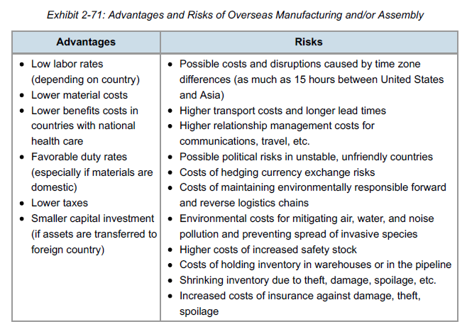

**Integrating the supply chain**

1. **Locate in the right countries.**

* Map all countries in the forward and reverse supply chains.
* Analyze the forward and reverse chains to see if selecting different geographic locations could make the logistics function more efficient and effective. (Countries differ by infrastructure, labor, stability, regulations, and taxes.)

2. **Develop an effective import-export strategy.**

* Determine the volume of freight and number of SKUs to move.
* Decide where to place inventory for strategic advantage. This may involve deciding which borders to cross and which to avoid as well as determining where goods should be stored in relation to customers. (Some shipping companies now add a “war risk surcharge” if transport is near a nation with civil unrest or war.) Both geographic location and distance from the suppliers and/or customer can affect total costs and delivery lead times.

3. **Select warehouse locations.**

* Determine the optimal number of warehouses.
* Calculate the optimal distance from markets.
* Establish the most effective placement of warehouses globally.

4. **Select transportation modes and carriers.**

* Determine the mix of transportation modes that will most efficiently connect suppliers, producers, warehouses, distributors, and customers.
* Select specific carriers.

5. **Select the right number of partners.**

* Select the minimum number of companies—freight forwarders, third- or fourth-party logistics providers—to manage forward and reverse logistics. In selecting logistics partners, also consider their local market and regulatory knowledge.

6. **Develop state-of-the-art information systems.**

* Reduce inventory costs by more accurately and rapidly tracking demand information and the location of goods. Developing state-of-the-art information systems may be difficult in some regions. Such situations make defining the processes and information flows vital.

Fourth-party logistics differs from third-party logistics in the following ways: (1) the 4PL organization is often a separate entity formed by a joint venture or other long-term contract between a client and one or more partners; (2) the 4PL organization is an interface between the client and multiple logistics services providers; (3) ideally, all aspects of the client’s supply chain are managed by the 4PL organization; and, (4) it is possible for a major 3PL organization to form a 4PL organization within its existing structure.

**Outsourcing considerations**

Before outsourcing logistics to a third- or fourth-party provider, a company should ask itself the following

questions:

**What are our current costs?**

**What customer skills does the contractor possess?**

**What are the contractor’s special strengths**

**Will the contractor hire the most-qualified partners (if necessary)?**

**Order Fulfilment Channels**

1. **Manufacturer storage with Direct Delivery**  
   model is common in business-to-business (B2B) settings. For B2C, it is used primarily for low variety, make-to-order goods that the customer is willing to wait for, since lead times can be long. Since there is only one echelon, the manufacturer has complete control over inventory and has low carrying costs. Shipments are typically in truckload (TL) or container load (CL)but logistics costs can be high
2. **Manufacturer storage with Drop Ship**The distributor or retailer may have a floor model but no inventory. This model would probably use transload and cross-dock facilities. It would be best for high-value, sporadic demand items; these might be make-to-order, customized, or postponed items that can be finished when the order arrives. Shipments may be in small lots, and thus transportation costs can be higher and lead times longer, but the manufacturer can control delivery service reliability
3. **Manufacturer to Distribution Centre to Retailer**

model is inventory-intensive. It is best for mass-produced, inexpensive goods with high competition. It produces strong product availability and high levels of customer service.

1. **Independent Distributor with Omni Channel Network**

independent distributor is the channel master, buying goods from multiple manufacturers (or other distributors) in bulk and aggregating them for a one-stop shop for retailers, local distributors, wholesalers, or direct customers. Manufacturers gain another sales channel and access to a larger market. Retailers and distributors can often buy assortments in TL or CL shipments and get economies of scale in pricing so they can sell at a competitive price for a profit.

1. **Independent Distributor with e-business network**

very similar to the previous model, but it depends more heavily on direct marketing to individuals through its own heavily branded website, which may sell all manner of goods. Alibaba and Amazon are examples. Direct shipment of goods to customers through parcel services is very common, but these organizations may also sell or ship through local distributors (which they may own) and will move slowmoving goods directly from manufacturers through local distributors rather than carry this inventory

**Direct-to-consumer model**

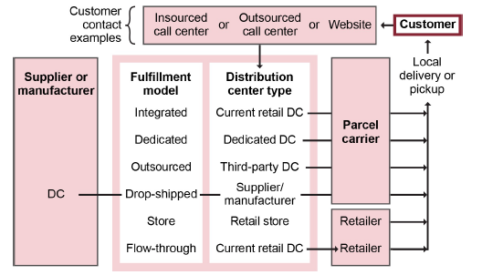

The increase in spending on fulfillment and technology is positively correlated with Amazon’s increase in net sales. For example, in 2012 Amazon invested about US$6 billion in fulfillment and earned about US$55 billion in net sales. In 2013 it increased its investment in fulfillment to about US$8 billion and earned about US$73 billion in net sales. Amazon’s investments in technology have similarly increased each year. Examples of these investments include equipping their new urban distribution centers with floor-to-ceiling racks that substantially increase storage space and purchasing a robotics company to provide robots for picking and put-away.

random-location storage is a storage technique in which parts are placed in any space that is empty when they arrive at the storeroom. Although this random method requires the use of a locator file to identify part locations, it often requires less storage space than a fixed-location storage method. Random-location storage is also called floating inventory location. This method maximizes cube utilization and can be rapid if the organization uses warehouse automation systems such as directed pick and put-away.

Fixed-Location Storage is a method of storage in which a relatively permanent location is assigned for the storage of each item in a storeroom or warehouse. Although more space is needed to store parts than in a random-location storage system, fixed locations become familiar, and therefore a locator file may not be needed.

* Using ABC Classification
* Grouping Functionally related items together
* Grouping High-Velocity Items together
* Grouping Items with Similar characteristics (like Hazardous, Refrigerated)
* Grouping Reserve Stock Separately

let’s say that the sum of all forecasted average inventories for an organization takes up 18,000 cubic meters (m3) in the highest forecasted year of a five-year plan. All inventory fits on a standard size pallet that, when full, is 1.2 meters deep × 1.0 meters wide × 1.5 meters tall = 1.8 m3. Calculating the need for storage bays divides the space requirement by the standard pallet cubic space: 18,000 m3/1.8 m3 = 10,000 storage bays. The organization multiplies this by a factor of 1.1 to account for partially filled pallets. This factor is based on historical analysis of existing warehouse usage. Then 10,000 × 1.1 = 11,000 storage bays needed.

**Determine the raw space footprint**Finding the square meters or feet requirement is useful because real estate is sold or leased using this unit of measure. To continue the prior example, 11,000 storage bays × 1.2 m2 of floor space (1.2 meters deep × 1.0 meters wide) = 13,200 m2 of floor space needed just for inventory.

**Factor in space for all inventory movements.**This is typically at least a multiplier of three. Organizations can analyze existing warehouses that use the same types of warehouse equipment to determine the right factor to use. In this example, the factor is 3, so the calculation is 13,200 m2 × 3 = 39,600 m2.

**Account for vertical space utilization.**

Determine how many levels of vertical storage will exist for pallet storage bays. For example, if there will be four levels of vertical storage for all bays, then the raw space footprint could be divided by four (e.g., ground storage plus pallet racks that are three levels high). In this example, there are four levels, so the calculation is 39,600 m2/4 = 9,900 m2.

**Add space for expansion or excess capacity.**Divide by a factor for the target utilization of the warehouse. This is a way of building in excess capacity. For example, if the target utilization rate is 80 percent, then the warehouse floor space would be divided by this percentage to find the total necessary space. This utilization rate would be set by organizational policy based on strategic and risk analyses. Since the rate here is 80 percent, the calculation is 9,900 m2/0.8 = 12,375 m2. This much land could be leased or purchased to build a new warehouse, or an existing warehouse of this size (and sufficient vertical height for the racks) could be leased or purchased.

The following value-added activities may take place in a warehouse:

* **Receiving**
* **Prepackaging** refers to when products are received in bulk from a supplier and subsequently packaged in smaller quantities or combined with other products to form kits or assortments.
* **Put-away**
* **Storing**
* **Order picking:** It is also known as order selection.
* **Moving**
* **Shipping**
* **Packaging & Marking**

**Warehouse functions**

Functions that add supply chain economic or service value include

1. Consolidation of materials for shipping
2. Break-bulk and cross-dock facilities
3. Postponement
4. Stockpiling seasonal inventory
5. Spot-stocking advance shipments
6. Assortment (similar to spot-stocking)
7. Mixing (similar to break-bulk).

**break-bulk** is Dividing truckloads, railcars, or containers of homogeneous items into smaller, more appropriate quantities for use.

**cross-docking** as the concept of packing products on the incoming shipments so they can be easily sorted at intermediate warehouses or for outgoing shipments based on final destination. The items are carried from the

incoming vehicle docking point to the outgoing vehicle docking point without being stored in inventory at the warehouse. Cross-docking reduces inventory investment and storage space requirements.

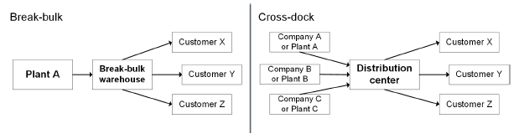

**Mixing** resembles break-bulk but involves shipments from more than one manufacturer. In a typical mixing

setup, the warehouse receives full-vehicle shipments of different products from manufacturers in diverse

locations, with each shipment receiving the full-load discount

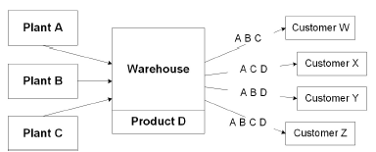

**Spot-stocking** is focused on strategic markets. It is allocating inventory in advance of heavy demand in

strategic markets rather than the inventory being stocked year-round or shipped as it’s being produced.

Advance shipments from a plant are sent to key markets to be sure they are close to customers in season.

Agricultural products are spot-stocked during the harvest season to put them close to key markets and then

are warehoused centrally for the rest of the year. Customers and producers benefit from spot-stocking of items in key markets to minimize the chance of a shortage during peak demand.

**Assortment warehousing** is a technique that stores the goods close to the customer to ensure short

customer lead times. Assortment benefits the customer by reducing the number of suppliers it has to deal with to acquire the assorted goods. It also reduces transport costs by allowing larger shipment quantities.

Conveyors offer several advantages:

* Inexpensive operating costs (especially with the roller type)
* Reduced labor costs (including costs for injuries and accidents)
* Efficient use of space (They fit into narrow aisles.)
* Ability of scanners to read bar codes or RFID
* Movement of far more inventory than trucks could move at far less cost (for example, moving coal from a mining area to a storage area)

The tradeoff is that using conveyors can potentially block access to the area where loading takes place.

The towline, and also called a towline conveyor, uses a four-wheeled container that is towed by a dragline, which can be mounted overhead or in the floor. Overhead lines are easier to install and move than in-floor lines. Some automated models can be uncoupled from one line and attached to another, giving them access to more than one dock. Overhead lines with automated decoupling provide more flexibility than standard belt or roller conveyors, but, on the whole, they are much less flexible than forklifts.

Towlines provide several advantages:

* Efficient use of space (They fit into narrow aisles.)
* Potential to improve inventory identification and accuracy

Tradeoffs include the following:

* Requirement of heavy capital investment when automated
* Need to invest significant time and money to design complex systems
* Relatively rapid obsolescence, especially in elaborate systems

Bridge and wagon cranes

For heavy lifting, warehouse managers may turn to cranes. The two basic types are bridge cranes and

wagon cranes. The “bridge” part of a bridge crane, is a horizontal girder, or pair of girders, that rests at each end on a truck.

The trucks run along tracks, giving the crane the ability to move objects horizontally in the direction of the

runway. They can also move objects perpendicular to the track, along the direction of the girder that runs

between the tracks. Because they are suspended, bridge cranes leave the floor space below them free for other activities and allow aisles to remain narrow to free up storage space. Bridge cranes are best used in low- to mediumvolume activities that require moving items that are large, heavy, or awkward to maneuver.

**Wagon cranes,** also called crane trucks or stacker cranes, offer the mobility that is provided by forklifts and

is absent from conveyor systems. They can negotiate narrow aisles and use all three dimensions of

warehouse space—height included. They are available in fully automated models that can lift objects in and

out of storage without the assistance of a human operator. Though these cranes are generally used to lift and swing objects that are too heavy or oddly shaped to be moved by other types of equipment, they can also be used to move objects horizontally for short distances.

Advantages of cranes include:

* Easy access to most areas within the lifting bay (bridge crane)
* Extension to areas outside the building (bridge crane)
* Ability to lift heavy objects that can’t be handled with forklifts or conveyors (especially the bridge crane)
* Ability to negotiate narrow aisles and to use all dimensions of a warehouse, including its height (wagon crane)
* Overhead suspension that leaves all floor space free for other uses (bridge crane)
* Available with radio control for remote operation (bridge crane) or fully automated for driverless picking and storing of items.

The main drawback of either type of crane is capital expense. The logistics manager may have to justify the

expense by documenting the crane’s appropriateness to the functions and space requirements of the

warehouse.

Carousels

A carousel consists of a series of bins mounted on an oval track with the option of multiple track levels. The

entire carousel rotates, moving inventory to a stationary order selector rather than requiring that person to go

to the inventory storage location.

The advantages of using a carousel include the following:

* It reduces labor required for order selection by reducing walking length and time.
* It can significantly reduce storage requirements, especially when stackable or multitiered carousels are used.
* Paperwork can be eliminated when the system uses computer-generated pick lists and carousel rotation.

A pick-to-light system uses a series of lights that indicate the right pick location and the number of items to

remove from that bin in the carousel. In some pick-to-light systems, a computer generates the pick lists and

operates the carousel.

Advantages include

* Efficient use of floor space
* Reduction of time and labor required to pick items from storage
* Available automation to further enhance productivity.

Automated guided vehicle systems

Automated guided vehicle systems (AGVS) perform much the same type of work as pallet trucks or tow

tractors with trailers, and they operate without a rider. Instead of running on tracks, they move along optical

tape or a magnetic wire in the floor, and they can be programmed to stop at various stations along their

paths. Models are available with tines for lifting pallets or with platforms; some models are specially designed

to move materials into high storage areas along narrow aisles.

Advantages include

* Programmability to increase flexible use without the expense of a human operator
* Ability to maximize use of warehouse space by operating in narrow aisles and providing access to high shelves.

The primary drawback is the high cost of acquisition.

Automated sorting (sortation) systems

Generally used with conveyors, automated sorting systems direct items on a conveyor into their proper

locations in a shipment. The system receives the required sorting information from a code on the master

cartons of the items to be shipped. Most automated sorters can be programmed to work at different speeds

to fit the requirements of particular shipments.

Advantages include

* Reduced labor costs
* Increased speed (up to one package per second).

Robotics

Robotics in warehousing is used to build and break down unit loads. To break down a load, the robot is

programmed to recognize product stacking patterns and place products in a predetermined position on the

conveyor belt. To build unit loads, that process is reversed. The following are advantages of using robotics:

* It can be used in situations that are difficult or dangerous for humans, such as high noise areas or areas with extreme temperatures (such as food freezers) or in working with hazardous materials.
* It has the capacity to integrate program logic and increase speed, dependability, and accuracy.

The drawback of robotics can be the cost. For example, Amazon paid US$775 million to purchase

warehouse robotics system manufacturer Kiva in 2012 to control the cost of these devices, which is still

US$15 to US$20 million per warehouse after the purchase. Amazon also restricted these systems to its exclusive use. Since there were no similar competitors, it took the industry four years to develop viable alternatives. By 2014, Amazon had 30,000 robots operating in 13 of their 110 warehouses. These robots pick up storage racks and move them to where they are needed, and since the robots require less space to operate, the warehouses that use them can hold 50 percent more inventory per square foot, cutting operating costs by 20 percent, or close to US$22 million, per warehouse. They also reduce the “click-to-ship” cycle to 15 minutes from 60 to 75 minutes. If implemented in all warehouses, it is estimated this would be a one-time savings for Amazon of US$800 million net of robot installation costs.

Live racks

The live rack contains roller conveyors and is designed to be loaded from the rear where it is elevated,

thereby using gravity to move product to the front. When an item or carton is removed from the front, the

items behind it slide forward. Using live racks provides these advantages:

* It reduces the need for lift trucks to transfer unit loads.
* It offers automatic rotation of product—the first product on the conveyor will be the first out (first-in, firstout, or FIFO).

A drawback of using live racks is that access to the stock in the middle can be hampered.

Automated storage and retrieval systems

The most advanced automated systems are called automated storage and retrieval systems (AS/RS). In

addition to automating both storage and retrieval, these systems feature very high storage racks that multiply

the capacity of the warehouse. The storage and retrieval functions are handled by a programmable AS/RS machine that moves both horizontally and vertically. The storage racks themselves may rise 100 feet or more, towering over standard warehouse racks. Because of the design of the storage and retrieval machine, the racks can be arranged along very narrow aisles.

The AS/RS machine is programmed at pickup and discharge stations located at the ends of aisles. Another

handling device, such as a towline, conveys incoming items to the AS/RS, which is programmed with

instructions for delivering the items to specific bins in a specific sequence. When an AS/RS is being sent into the racks to retrieve items for an outgoing shipment, software helps it find the required items in the most efficient way. The AS/RS machine moves through the racks at high speeds—300 to 400 feet per minute horizontally and 100 feet per minute vertically. Computers may be dedicated to the AS/RS station.

The advantages of AS/RS systems include

* Maximum storage density per square meter or foot of floor space
* Tight control of storage and retrieval for high speed and freedom from error and pilferage
* Reduction of labor costs (and human error).

The obvious drawback is cost. AS/RS systems are complex, large, and very expensive. Other disadvantages

may include added labor required to properly put away materials, dedicated space, loss of flexibility (it’s not

easy to move such a system), and equipment failures.

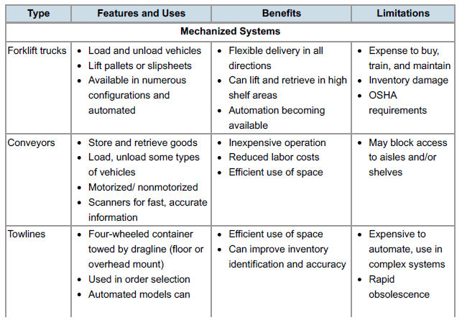

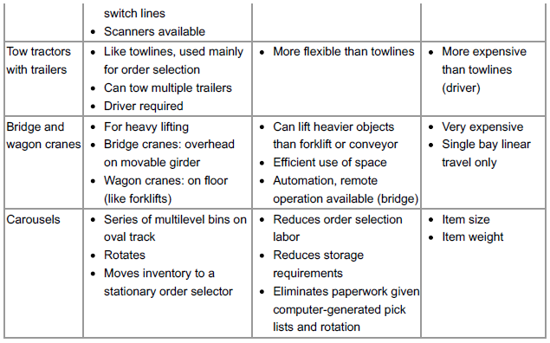

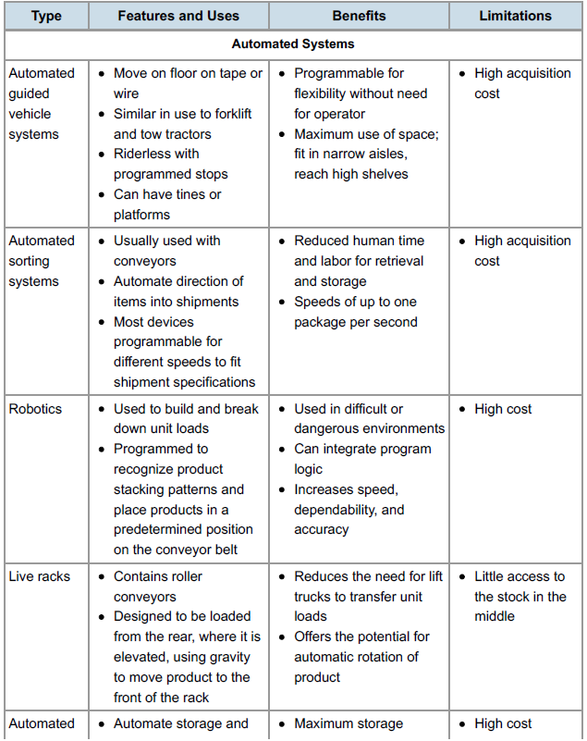

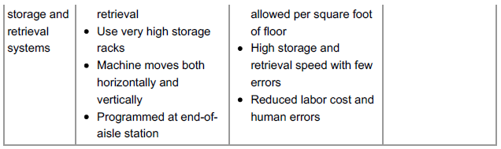

Automatic identification technologies

“Automatic identification technologies” or “automatic identification and data capture (AIDC)” are umbrella

terms used to refer generally to bar codes, RFID, voice recognition, smart cards, optical scans—any

technology that offers automated scanning of information from a product. These technologies may also refer

to advanced uses of RFID and the internet, a conjunction sometimes called “an internet of things.”

As the price of RFID technology drops and as supply chains synchronize networkwide enterprise resource

planning software and powerful hardware, benefits such as the following will become commonplace:

Automation will allow supply chain partners to check the items in a shipment without unbundling a

pallet.

Inventory tracking will be continuous, automated, and always current.

Tracking of individual items electronically will reduce—if not eliminate—theft by signaling when items

are moved inappropriately.

Counterfeiting will be reduced when each item has a unique identifier.

The supply chain manager will be able to select from the gathered data just the key information needed

to run the operation better.

***Transportation***

**Line haul costs** are basic costs of carrier operation to move a container of freight, including driver’s wages and usage

depreciation. These vary with the cost per mile, the distance shipped, and the weight moved.

Line haul costs include the following:

* **Vehicle costs.** A supply chain partner can choose between controlling its own fleet of vehicles, hiring transportation as needed, or contracting with a carrier for a longer term. With a company fleet, the company incurs internal costs for financing, leasing, and depreciation; with commercial or public transportation, the company incurs external costs
* **Driver/operator costs.** Unless the mode of transport is a pipeline, transportation includes the cost of labor required to operate the vehicle—drivers for trucks; pilots, copilots, and crew for air transport; engineers for rail; and so forth. Driver shortages can drive up costs due to higher market wages, difficulties with certification, lack of investment capital, and expanded regulation.
* **Vehicle operating costs.** Operating and maintaining a fleet of owned or leased vehicles requires expenditures for repairs, cleaning, parking, etc. As fuel prices rise, operating expenses increase for road, air, rail, and water transportation. One way in which steamship companies are minimizing their costs is by running their ships more slowly to consume less fuel, which increases delivery time. For example, Wärtsilä, a ship engine producer, has calculated that reducing cargo ship speed from 27 to 18 knots results in a 59 percent fuel savings at a cost of one extra week in transit between the far East and Europe, or fuel savings of more than US$2 million for a one-way trip. Other companies use semi trucks without sleeping cabs or extra wheels to reduce the overall weight.
* **General and administrative costs.** Funds must be allocated to management of the transportation function.
* **Insurance and security costs.** With a private fleet, a company pays insurance costs to cover a variety of security concerns. Products may be damaged, lost, or stolen in transit. Transporting hazardous materials requires extra expense for insurance coverage, for security, and to comply with regulations. Air, rail, and water transport must provide protection against terrorism as well as vandalism and theft.

***Minimal harm to the environment***

the Clean Truck Program was signed into law in 2008, requiring diesel-powered, short-haul drayage trucks to meet new environmental standards that will reduce their air pollution by 80 percent. (Drayage trucks transport shipping containers from docks to off-site warehouses.)

The U.S. EPA’s Clean Air Nonroad Diesel Rule (also known as Tier 4), affecting industrial equipment,

generators, and transportation infrastructure such as heavy forklifts and airport service equipment, was fully

implemented in 2015, reducing allowed particulate matter and nitrogen oxides. Ultra-low-sulfur diesel was

also fully implemented in 2014 for nonroad, locomotive, and marine engines. (It was fully phased in for trucks

in 2011.)

The European Union has established low emission zones (LEZs) in which high-polluting trucks are

prohibited. Specifically, regulations prohibit higher-emission heavy-duty diesel trucks from entering certain

EU cities. Vehicle emissions are classified into Euro standards for the vehicles they apply to; trucks are rated

Euro VI, Euro V, Euro IV, etc., with the lower numbers having more restrictions due to their higher emissions

or lack of particulate filter or catalytic converter. Before a truck enters into an LEZ, the driver must know the

emissions standard for that particular vehicle.

Three situations provide the most frequent examples of the use of vehicles for temporary storage:

**Short-term storage.** Trailers and railcars sometimes park at a facility without being unloaded if the contents need to be stored but are scheduled to move again in a few days. In the global arena, logistics parks (designated areas for storage and distribution built to complement industrial zones) are a growing option for efficient short-term storage. Some trucking companies have their trucks set up with two trailers so the driver can park one temporarily outside an urban area. After the first delivery, the driver retrieves the second trailer and delivers those goods. Logistics warehouses in China are classified as either bonded or nonbonded. Bonded logistics parks (BLPs) are often located near ports and serve as cost-effective holding areas where shipping orders can be consolidated from various locations before being exported. Nonbonded logistics parks, which have cheaper rental rates than BLPS, are increasingly being developed on the expanding road network (such as that connecting

Shanghai to other cities in the Yangtze River delta).

**Crowded facility.** If a warehouse is too full to accept the contents of an arriving truck or railcar, some of the contents of the warehouse may be loaded into another vehicle. That vehicle then takes a slower and often cost-equivalent or cheaper route to its destination. In other cases, the limited shipping dock capacity at the outgoing facility may be the reason to ship something early but by a slower method. In some cases, the cost-equivalent but slower method will be intermodal. The tradeoff in extra transportation time and costs must be balanced against the enhanced storage capacity.

**Changed destination.** With global positioning to track in-transit inventory, while one generally needs to select a destination to release an order, the destination could be changed mid route. Reasons to divert a shipment of goods while in transit include to make the best use of available warehouse space or to accommodate changes in customer orders, such as last-minute cancellations or new orders. In the case of crude oil, in many cases the oil is traded on the market as soon as the tanker is under way toward a general destination like the U.S. West Coast, and the delivery time frame continually grows shorter as trading continues. The final owner chooses the specific destination based on the best available deal.

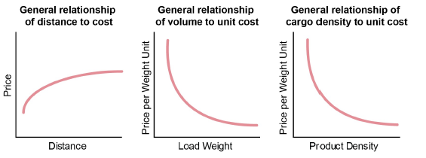

***Stowability***

Items with odd shapes that prevent them from efficiently sharing cargo space cost more to ship than items of

similar density and weight that stow more efficiently

***Handling***

Challenges involved in handling the cargo during the loading and unloading of vehicles affect pricing, like:

* Is special equipment required to move the cargo?
* Are physical dangers involved?
* Have the materials been properly grouped and packaged for ease of handling and storage all along the logistics supply chain?

The most productive, cost-effective **packaging** meets the following criteria:

* Efficiency of handling during loading, unloading, and storage
* Protection against damage to the cargo
* Communication (that is, packages should be labeled for ease of identification, tracking, customs, and handling)
* Low environmental impact

Major **liability** concerns include the following:

* Susceptibility to damage. Televisions, for instance, are more of a liability issue than paper products.
* Perishability. Fresh fish pose a series of problems. Any delays in shipment or refrigeration failures can be ruinous.
* Value per pound. Shipping precious metals or antiques exposes the carrier to liability risk.
* Susceptibility to theft. Some goods are more valuable than others to thieves and smugglers. The likelihood of theft is also increased if the cargo will sit for part of the trip or will change hands frequently. Shipments awaiting customs clearance are especially susceptible.

A **backhaul**, is the return trip of a [commercial truck that is transporting freight](https://www.txintlfreight.com/trucking-freight/heavy-haul-trucking/) back over all or part of the same route it took to get to its current location. Both freight brokers and motor carriers rely heavily on one another when it comes to backhauls. They are also sometimes referred to as “deadheads” in the trucking industry.

**Transportation Modes**

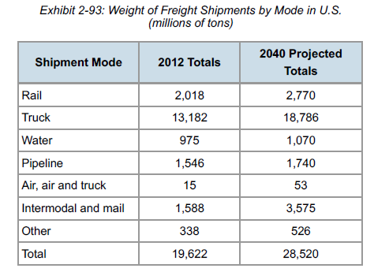

**Rail transport**

* Rail transport is very fuel-efficient. Based on data provided by the Association of American Railroads (AAR), in 2014 U.S. railroads averaged 479 ton-miles to the gallon (a railway fuel efficiency measurement that means an average train moved a ton of freight across 479 miles on a gallon of fuel), which makes it four times more fuel-efficient than truck transport.
* Transport by rail rather than truck reduces greenhouse gas emissions by 75 percent.

While deregulation stabilized rail’s percentage share of the intercity transport market, it resulted in an ongoing

decline in the number of large carriers, miles of track, and total revenues as rail carriers abandoned

unprofitable lines and cut rates to be competitive. The U.S. trucking industry was the major beneficiary of the decline in rail.

In 1995, rail hauled 20.2 percent of freight in the EU, but this steadily declined over the years and in 2010 was

at 16.2 percent. Over the same period, road transport increased its share of freight transport from 67.4

percent to 72.7 percent.

On the other hand, rail transportation has grown in importance in the national and international movement of

goods in Asia. The following are reasons often cited for the increase:

* Twelve of the 30 landlocked countries of the world are located on the Asian continent, with the nearest ports often several thousands of kilometers/miles away.
* The distances linking the origins and destinations (both domestically and internationally) justify the economics of rail transport.
* There is a reliance on ports to connect national economies to the world’s markets, especially in the context of growing containerization and intermodal transport
* Several Asian countries are major exporters of mineral resources, and rail transport is crucial to their logistics.
* A steadily increasing volume of goods is being exchanged globally.
* Rail is recognized as environmentally friendly and safe.

The rough ride over steel rails and the jarring impact of coupling tends to cause more damage to cargo than occurs with other modes of transportation (about 3 percent of tonnage)—hence, in part, the focus on low-value, durable freight. Also, the relatively low rate structure—about one-tenth the cost per ton-mile of truck transport—makes rail transport attractive for low-value freight. As the value of the cargo declines, the cost of transportation consumes a greater portion of the selling price.

Limitations

1. Though rail lines reach more destinations than are available to waterborne carriers, their access to multiple destinations pales in comparison to the reach of highways
2. Railroad transport is relatively slow. This can result from the necessity of stopping at numerous locations, from the slow procedures required to decouple and recouple cars in a switching yard, and from practical restrictions on speed related to current infrastructure.
3. Rail transport tends to cause more damage to fragile products than other modes of transport, and consequently it requires special care to be taken in packaging fragile products.

**Motor carriers (or Trucks)**

There are approximately four million miles of highway in the United States alone

American Trucking Association and IHS Global Insight research predicts that U.S. freight tonnage will grow about 24 percent over 2013 amounts by 2025, causing freight revenues to increase by 72 percent.

Currently there are about 65,000 general freight trucking companies in the U.S. (The 50 largest companies account for 40 percent of revenue.)

The trucking industry comprises three segments: truckload (TL), less than truckload (LTL), and specialty.

* The TL segment includes many carriers who compete on their rates. A truckload shipment weighs over 15,000 pounds (6,818 kilograms). Because they are fully loaded, trucks in the TL segment generally travel straight from the loading dock to the destination; they don’t have to stop and take on more pallets to fill up the trailer.
* In the LTL segment, trucks start with loads of less than 10,000 pounds (4,536 kilograms). Because they have space in the trailer, these trucks often have to stop at intermediate locations to take on more cargo. This, of course, extends their delivery time, uses more fuel, and raises labor costs for the drivers and dockworkers. The higher costs of doing business in this sector have led to more consolidation than in the TL sector.
* Specialty carriers include companies such as United Parcel Service (UPS) and Federal Express.

The Airline Deregulation Act is a 1978 [United States federal law](https://en.wikipedia.org/wiki/United_States_federal_law) that [deregulated the airline industry](https://en.wikipedia.org/wiki/Airline_deregulation) in the United States, removing [federal](https://en.wikipedia.org/wiki/US_federal_government) control over such areas as fares, routes, and market entry of new airlines.

The Motor Carrier Regulatory Reform and Modernization Act, more commonly known as the Motor Carrier Act of 1980 (MCA) is a [United States federal law](https://en.wikipedia.org/wiki/United_States_federal_law) which [deregulated](https://en.wikipedia.org/wiki/Deregulation) the [trucking industry](https://en.wikipedia.org/wiki/Trucking_industry_in_the_United_States). It was a part of a sweeping reduction in [price controls](https://en.wikipedia.org/wiki/Price_controls), [entry controls](https://en.wikipedia.org/wiki/Barriers_to_entry), and collective vendor price setting in United States transportation, begun in 1970-71, and continued into the 1980s, collectively seen as a part of deregulation in the United States.

Tradeoffs

Although motor carriers benefit from low fixed costs (trucks being much cheaper than ships or planes), they

do have to contend with high variable costs. Trucking companies are beset by rising costs for equipment,

repairs, and the wages paid to drivers and the laborers who load and unload cargo. Trucking is more labor-intensive than its competition, so it is impacted more than other modes by rising labor rates.

Since deregulation in the U.S. in 1980, competition for customers has increased in the trucking industry. The

result has been lower rates, which are a boon for the logistics manager but have caused many carrier bankruptcies.

**Water transport**

Water transportation forms an important part of domestic and international trade. It includes several categories: inland waterways, lakes, coastal and intercoastal ocean, and international deep sea. In international shipping, water is the dominant mode, and it is the most inexpensive method of shipping highbulk, low-value commodities.

A barge could hold the weight equivalent of more than 30 fully loaded double-trailer trucks.

Rather like trains, however, barges and other floating carriers find their most fitting use in conveying lowvalue,

high-density cargo over long distances, with loading and unloading accomplished mechanically.

Probably the largest vessels on the water are the oil tankers. They are usually classified by function and

size. There are two functional types of the vessels: the crude tankers, which carry unrefined crude oil from

the field to refineries, and the product tankers, which carry petrochemicals from refineries to market areas.

Sizes range from inland or coastal tankers to gigantic supertankers. Most newer tankers have a double hull,

thereby creating extra “safety” space between the storage tanks and the hull. Each very large ship can

transport two million barrels of oil. In light of recent serious oil spills in oceans, both the U.S. and the EU

have passed laws regarding pollution and double hull requirements that are in effect as of 2015 and 2010

respectively.

* The primary value that water transport provides the logistics manager is low cost. At less than a penny charged per ton-mile, shipping by water is even cheaper than using a train.
* Water carriers also make highly efficient use of fuel. According to their 2012 annual report, the American Waterway Operators found that one gallon of fuel moves one ton of cargo 616 miles by inland barge, 478 miles by train, and only 150 miles by truck.
* Water transport can also relieve congestion on crowded highways—a significant consideration in the European Union and near urban centers generally. In the Asian region, more than one billion tons of freight moves by inland water carrier annually on waterways such as the Yangtze and the Ganges, and one-third or more of all cargo travels by water in Bangladesh, the Lao People’s Democratic Republic, and Myanmar.
* In some areas of Asia where there are few roads or railroads, waterways constitute the sole means of connecting remote rural communities to urban centers.

Containers are typically 8 feet/2.44 meters high by 8 feet/2.44 meters wide and of various lengths, from 20

feet/6.1 meters to 53 feet/16.15 meters. Many new containerships are capable of carrying 18,000 20-foot

equivalent units (TEUs) or the equivalent of that many 20-foot containers

In the United States, water transport has remained stable, in the range of 15 to 17 percent of total ton-miles, over the past five decades. The ships used on the Great Lakes (US) are deep-water vessels, which can harbor only in deep-water ports such as those on the Lakes or the coasts. Canal and river transport relies on flat-bottomed barges with more flexibility as to where they can travel. In the EU, freight moves on such major rivers as the Rhine, the Rhone, the Danube, and their many tributary canals. China has publicly committed to strengthen the transport system for its inland waterways by 2020. It is estimated that by then it will have 19,000 kilometers of navigable waterways and will have further developed transportation on the Yangtze, one of its major rivers for transporting coal and steel. It also promises to build more river ports and enhance the infrastructure to accommodate an increase in capacity.

The primary products transported on inland waterways include commodities such as cement, chemicals, and

some agricultural products. U.S. Great Lakes vessels mostly carry ore, coal, and grain. The bulk of this trade

qualifies for exemption from government economic regulation.

Tradeoffs

There are two obvious drawbacks that might prevent a logistics manager from using water transport: limited

accessibility and lack of speed. There are fewer miles of inland waterways than there are roads and railroad

tracks, and if the shipper and the recipient have no direct access to a port, they have to use another mode of

transportation to get products to and from the carrier.

Once on the water, progress is slow on a barge or in a deep-water vessel. Not only are barges—or the

diesel-engine vehicle that tows them—slow-moving, but on natural waterways they must make their way

through a series of locks. When rail lines run parallel to a waterway, trains make strong competitors for water

carriers for transporting the kinds of heavy, low-value goods carried on barges. The tradeoff is between the

greater speed of the train and the far lower rates for water transport.

Barges using major waterways must compete with other important uses, such as passenger transport,

fishing, recreation, drinking water, and energy generation. Discharges from cargo carriers can be a

significant source of pollution, along with runoff from mining and agriculture, and pollution is incompatible

with the competing uses of rivers for recreation and drinking water. Some of the major waterways in Europe,

which pass through many countries with separate and various levels of regulation, have become seriously

polluted over the years.

The increase in import volumes, aging port equipment, shortage of rail capacities, and limited numbers of truck drivers and carriers can lead to delays. For example, the 2015 U.S. West Coast port strikes created severe backlogs for the trucking and container/tanker shipping industries. With 70 percent of imports from Asia coming through the West Coast, the strike impacted all organizations shipping or awaiting their goods. Ports were gridlocked, and dozens of containerships were queued for miles during the nine-month strike

**Pipeline transport**

Not only are pipelines unique in being stationary carriers; they generally move their cargo in only one

direction—thus eliminating the need to be concerned about backhaul carriage. Also, no packaging is

required to move cargo through a pipe. The pipe is the package and also a storage facility.

Pipelines are special, too, in that they are available for continuous use on all days, in all seasons, and at all

hours. Unlike air, motor, and rail carriers, they pose no noise problems. They will, however, cease to move

cargo during power outages, since the pumps that cause the contents to flow depend upon electricity. Also

on the downside, pipelines are expensive to construct and maintain. Since pipelines are fixed in place, they

have the highest fixed costs of all modes of cargo transport but the lowest variable costs—a cost structure

otherwise similar to that of rail transport. The fixed costs are mainly due to right of way, construction of

facilities, and pumping capacity. The costs of operation are very low.

In general, the carrying capacity of pipelines increases relative to pipe diameter. Also, increasing diameter

reduces the amount of liquid in contact with the pipe for a slight friction decrease and efficiency gain.

In the past, safety has been one of the major benefits of pipeline transport. They are unaffected by weather

conditions and highly unlikely to rupture. Cargo damage and loss are virtually nonexistent. The main natural

enemy of the pipeline is seismic activity. Aside from crude oil and petroleum products, pipelines carry manufacturing chemicals, municipal sewage and water, and dry materials such as cement that can be pulverized or flour that can be suspended in liquid.

Pipelines are of limited use in international carriage, because they are vulnerable to political disputes between the countries whose borders they cross—also a problem for other modes of transport that cross boundaries.

**Air transport**

Any commodity can travel by air, subject only to restrictions on weight and size. The military, perhaps the world’s first and best logistics manager, air-lifts heavy equipment to battle zones. Cargo destined for travel in an airliner’s hold requires significantly less packaging. Air transport benefits from low fixed costs, ranking second in that regard only to over-the-road motor carriers.

Airports are generally constructed and maintained by taxpayers—federal or local—with gates leased to

carriers. Shippers can afford to purchase or lease their own fleet of airplanes. Variable costs, however, are

high, due to the rising cost of fuel and the expenses accruing to a very labor-intensive business.

Tradeoffs

Speed is the air carriers’ primary advantage, with low loss and damage rates tagging along behind, but with

speed comes a higher price tag. At around three times the cost of road carriage and more than 30 times the

cost per ton-mile of rail carriage, air transport exacts a high cost in exchange for rapid delivery. Generally speaking, to justify the transport cost, air cargo almost always has to be high in value, at least to the buyer. For example, fresh fish for high-end restaurants is usually shipped via air.

**Intermodal transport**, which includes package delivery and container services, integrates the different modes of transportation in various combinations to take advantage of their specific capabilities. Since deregulation, the legal barriers to mixed mode and specialized services have decreased and new types of specialized or hybrid transport providers have entered the marketplace.

the top five shipping companies in the world, from largest to smallest, as UPS, DHL Express, FedEx, the United States Postal Service (despite serving only the U.S., it had 2010 revenue of over $67 billion, employs over 600,000 people, and has the world’s largest civilian fleet), and Schenker AG of Berlin. Many other express carriers exist, such as OCS, a provider of worldwide delivery and logistics services based in Canada since 1963, and Aramex, based in Amman, Jordan, which primarily serves the Mideast.

Intermodal services

**Piggyback service (TOFC, COFC, roadrailer).** the placement of a truck trailer or a container of cargo on a railroad flatcar, hence the names TOFC (trailer on flatcar) or COFC (container on flatcar). The cargo travels part of its way via truck and the rest of the way by train. Roadrailers are trailers that ride on either regular tires/wheels or steel wheels. A simple change of wheels allows them to ride on the highway behind a tractor or be pulled along the tracks as short railcars.

**Trainship or containership service.** “Trainship” and “containership” refer to mixed mode transport

that includes water carriage. It also is sometimes referred to as “fishyback.” As the names signify, the

cargo is loaded into a truck trailer, a railcar (trainship), or a container that also spends part of its

shipment time on board ship or barge.

**Truck-plane services.** Air transport generally requires some intermediary surface travel (sometimes

referred to as “birdyback” services), since airport terminals are not usually located near manufacturing,

harvesting, or extraction sites, and those sites are generally not equipped with their own private airstrips.

**Freight truck on railcar.** In Europe (for instance, in Austria), there are now laws restricting driving at night by truck drivers hauling freight. So a truck is loaded onto a flatbed railroad car, which is transported to another location via rail while the truck driver sleeps on the train to continue moving during prohibited hours (the required rest period).

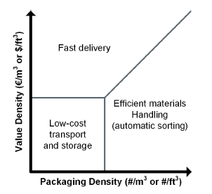

shows that a reliable method to find the best mode of transportation for shipping a specific

product type is to compare the product’s value density (the value of units being transported per cubic foot or

meter) versus its packaging density (the amount that can be packed per cubic foot or meter).

Let’s look at an example.

Postal offices or organizations do not own the letters they ship, so for them the value density is about zero.

They collect letters from letterboxes and then bring them to a hub. Once there, the letters need to be sorted

and sent forward to the next hub. At this second hub, the letters are re-sorted according to street address.

The packaging density is very high (more than 10,000 letters per cubic meter), so the focus is on automatic

materials handling. (In the Netherlands all letters are sorted on sorting machines.)

Bricks are an example of a product with low value density and low packaging density. The value per brick is

very low, and bricks are sent to customers on pallets, so the packaging density is also low. The preferred

way to treat this kind of low value/low density goods is to load the pallets at the manufacturing plant and

directly transport them to the customer site using a low-cost transportation mode.

When looking at manufacturers of copy machines and digital cameras, you will discover that they use

different modes of transportation. Copy machines have a low value density and are shipped in containers

from the far east to the U.S. and Europe. Cameras have a high value density, so the emphasis is more on

how to recover the invested money quickly. These products will be transported by airplane.

**Types of carriers**

Common (public) carriers

**common carrier** is transportation available to the public that does not provide special treatment to any one party and is regulated as to the rates charged, the liability assumed, and the service provided. A common carrier must obtain a certificate of public convenience and necessity from the Federal Trade Commission for interstate traffic.

The U.S. STB governs entry into the common carrier market for rail, motor, and marine transport; the U.S. Department of Transportation (DOT) regulates entry into air transport.

Private carriers

A private carrier is a company that owns or leases a fleet of vehicles to transport its own products. A private

carrier that purchases a fleet of vehicles incurs the costs of ownership—such as maintenance, insurance,

depreciation, and financing. The vehicles also count as assets on the balance sheet, which worsens certain

financial ratios.

Contract carriers

Unlike common carriers, contract carriers are not required to make their services available to the general

shipping public, though they do require government authorization to do business and are governed by

economic regulations.

Exempt carriers

Exempt carriers are not subject to economic regulation of their rates and terms of service. They are,

however, responsible for compliance with state laws governing licensing and regarding safety, and in the

U.S. they must publish their rates if they operate across state lines. (Most exempt carriers operate locally.)

The market determines their rates, services, and availability. Exemptions are granted for specific commodities and for certain areas of operation, such as the zones around airports. Typical exempt commodities include raw materials and unprocessed agricultural products.

In addition to providing a deadline for payment without penalties, many organizations offer a discount to

encourage early payment. For example, payment terms of 1/10 net 30 mean that the buying organization will

receive a 1 percent discount if payment is made within 10 days but has up to 30 days to make the full (net)

payment with no late penalties

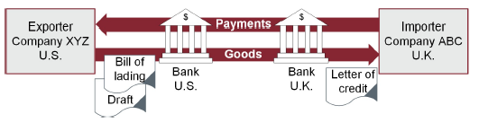

A letter of credit is a letter in which a bank assures the seller that the buyer can pay the purchase price of the goods and that the bank will therefore honor the buyer’s checks to the seller up to that amount. The bank makes this assurance either because it has reason to believe that the buyer’s credit is good or because the buyer has an account with the bank.

The sequence of events goes something like this:

**L/C is issued.** After agreeing to the terms of sale, the buyer/importer goes to its bank and gets a letter of credit demonstrating that the bank has faith in the buyer/importer’s ability to pay the purchase price.

**Seller’s bank is notified.** The buyer’s bank notifies the seller’s bank that the L/C has been issued.

**Seller ships cargo.** Confident of receiving payment when the goods have arrived as specified, the seller has the cargo shipped. The carrier sends a B/L (or waybill for air carriage) to the seller’s bank.

**Seller asks its banker for money.** After shipping the cargo, the seller sends a draft for the purchase price to its banker, who now has the seller’s draft plus the carrier’s B/L.

**Seller’s bank asks buyer’s banker for money.** The seller’s bank forwards the documents to the buyer’s bank. The B/L from the carrier usually assigns ownership of the goods to the buyer’s bank, not directly to the buyer.

**Buyer’s bank waits for cargo (perhaps).**

**Everyone gets paid.** At the time specified—say, when the buyer approves the cargo and accepts delivery—all outstanding drafts are honored. The buyer pays its banker; its banker pays the seller’s banker; the seller’s banker pays the seller. The contract can specify a grace period. If the goods turn out to be damaged, substandard, or otherwise unacceptable, the buyer may reject the shipment and is at risk of not getting a refund and having to write the whole deal off on its taxes.

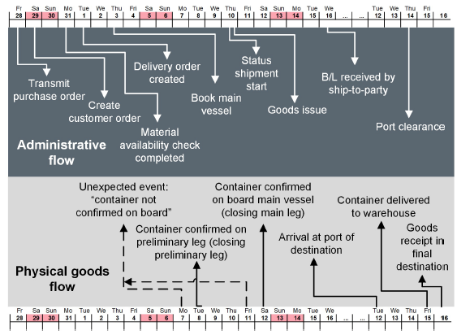

Currency exchange risk creates **operating exposure** for an organization, which is the risk introduced by flexible exchange rates when operating in the global environment, including production, storage, and buying and selling prices.

If you aren’t dealing in the same currency as your counterparty in an import-export transaction, you have to

find ways of making or collecting a payment with minimal risk. One technique is currency hedging, which is

used to offset the risks associated with the changing value of currency. The most common tool used in currency hedging is currency futures, in which one party agrees to buy/sell a fixed amount of a given currency at a fixed exchange rate on a fixed date in the future. Futures are traded on organized exchanges or clearinghouses; these third parties reduce counterparty risk by serving as intermediaries to both buyer and seller.

The cash-to-cash cycle time (also called the cash conversion cycle) is a key metric for measuring the

efficiency of the flow of funds.

**Incoterms** (International Commercial Terms) trade terms are a set of rules established by the International Chamber of Commerce that provides internationally recognized rules for the interpretation of the most commonly used trade terms in foreign trade and are routinely incorporated in the contracts for the sale of goods worldwide to provide guidance to all parties involved in the transaction.

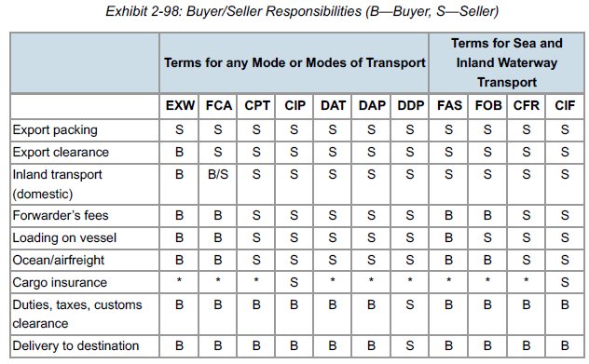

EXW – Ex-Works

FCA – Free Carrier

CPT – Carriage Paid To

CIP – Cost & Insurance Paid To

DAT – Delivered at Terminal

DDP – Delivered Duty Paid

FAS – Free Alongside Ship

FOB – Free On Board

CFR – Cost & Freight

CIF – Cost Insurance & Freight

A **tariff,** is “an official schedule of taxes and fees imposed by a country on imports or exports.”

**global trade management** is the management and optimization of shipments across international borders including: ensuring compliance with all international regulations and documentation, streamlining and accelerating the movement of goods, to improve operating efficiencies and cash flows.

**freight forwarder** is the “middle man” between the carrier and the organization shipping the product. Often combines smaller shipments to take advantage of lower bulk costs. a **foreign freight forwarder** is an entity that picks up goods at the production site and coordinates transport to the foreign customer’s location. In the United States, they are regulated by the Federal Maritime Commission.

Forwarders may perform many different functions in the course of moving goods across international

borders, including

* Quoting carrier rates
* Arranging charters or booking vessel space
* Preparing and presenting documents
* Obtaining insurance
* Handling payments
* Translating
* Tracing and expediting shipments
* Arranging inland transportation.

certification is available for ocean forwarders from the U.S. National Customs Brokers and Forwarders Association, which will designate someone as a “Certified Ocean Forwarder” based upon a combination of experience and passing a certification exam.

Airfreight forwarders may be either independent contractors or affiliated with a single air carrier. They require

neither licensing nor certification. However, they may obtain certification from the relevant country’s regulatory body. In the U.S., this is the U.S. Federal Aviation Administration (FAA). In that jurisdiction, clients generally prefer to work only with FAA-certified airfreight forwarders. A major source of competition for airfreight forwarders comes from the carriers themselves, who can work directly with shippers. Companies like FedEx and UPS Air also compete with forwarders for small shipments.

**Non-vessel operating common carriers** (NVOCC) buys space on inland carriers and resells it to shippers at a marked-up price. NVOCCs handle only the part of the shipment traveling from a port to the importer’s dock or from an exporter’s dock to a port.

At the time, trains and trucks often returned to port empty after unloading cargo at inland destinations and charged the shipper for both halves of the round trip—even though the shipper made no money on the turnaround. The NVOCCs were able to solve the problem by finding cargo for the return trips to port.

NVOCCs can be distinguished from forwarders in three ways:

* NVOCCs actually buy and resell space on carriers; forwarders do not.
* NVOCCs perform the physical work of consolidating, loading, and unloading cargo; forwarders do not provide labor.
* NVOCCs can handle the freight in many cases, such as shipping by a motor freight carrier from Charlotte, North Carolina, to Hawaii.

Though they neither own nor operate vessels, NVOCCs are regulated in the U.S. by the Federal Maritime

Commission, which requires them to publish rates and not discriminate in hiring.

These days, the information required to clear customs passes through computer interfaces, such as the

Automated Broker Interface System in the United States and the Pre-Arrival Review System in Canada.

**Export management companies and export trading companies**

When companies want to expand from domestic to foreign markets, they may turn for assistance to foreign

trade specialists in either export management companies (EMCs) or export trading companies (ETCs) rather

than adding internal expertise.

The EMC is generally not an exporter itself but rather a consultant to the exporters that hire it. The ETC, on the other hand, is itself an exporter. An ETC, by contrast, looks for companies making goods that it wants to buy and resell in a foreign market. Its functions, therefore, may include locating importers to buy the goods, overseeing export arrangements, preparing and presenting documentation, arranging transportation overseas and inland, and complying with regulations.

**Ship brokers and ship agents**

Ship brokers and ship agents assist exporters with the details of arranging ocean transport. A ship broker is

an independent contractor that brings exporters together with ship operators that have appropriate vessels

available to carry the shipper’s freight. With detailed knowledge of carrier schedules, the broker can help the

exporter find a ship that will be in port when its cargo is ready to travel. A ship agent works for the carrier

rather than being an independent contractor. When a ship is headed for port, the ship agent arranges for its

arrival, berthing, and clearance; while the ship is in port, the agent coordinates unloading, loading, and fee

payment. Shippers contact ship agents for information about the arrival and availability of ships.

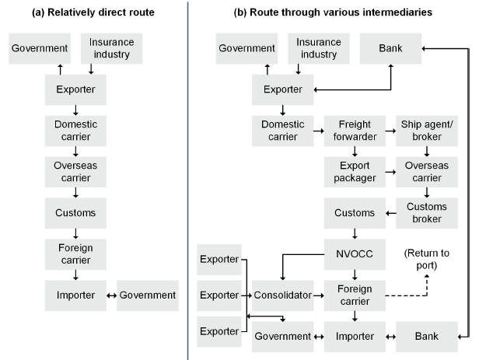

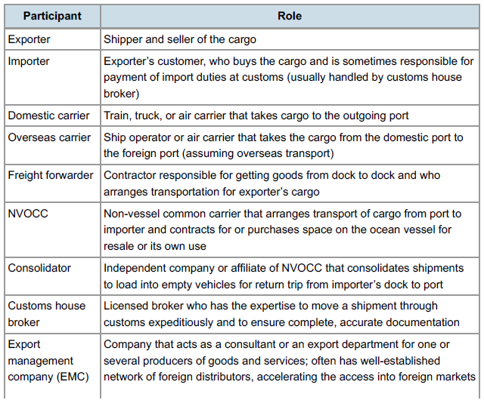

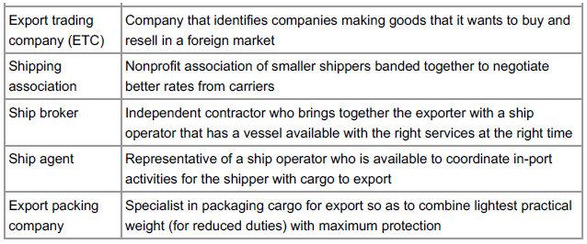

**Harmonized Tariff Schedule** is the mechanism by which international tariffs are standardized. Importers and exporters classify all goods moved across international borders using the Harmonized System of the country of import. Then based on this classification the HTS is used to determine the amount of tariff they must pay. It is administered by the World Customs Organization in Brussels, serves as a set of standard numerical descriptions of products exchanged in export-import transactions. A synonym is the **harmonized system classification codes.**

The HTS coding system is used by more than 200 countries and economies as a basis for their customs

tariffs and for the collection of international trade statistics. Over 98 percent of the merchandise in

international trade is classified in terms of the HTS. The basic HTS number is made up of six digits. Each country can assign up to four additional numbers, to make a 10-digit code. The United States, for example, maintains two versions of the harmonized code, both expanded to 10 digits. One is used for imports and is administered by the U.S. International Trade Commission (USITC); the other, called Schedule B, is used to classify exports and is administered by the Census Bureau. Many other countries use six- to nine-digit versions of the HTS number.

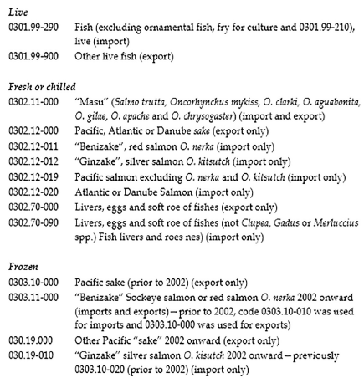

According to the World Trade Organization (WTO), the declared value of the cargo should ideally be the actual price paid (or to be paid) by the importer. Goods shipped between one company’s divisions located in different countries are valued by a transfer price, which is a standard cost plus a surcharge. The WTO recognizes other reasonable ways of determining value, such as the value of identical or similar merchandise.

Duty drawback is a refund of all or part of duty paid on goods that were first imported and then reexported.

Governments differ on the details of drawbacks. In every case, however, the importer pays the import duty

when the goods initially come into the country and then applies for the drawback after reexporting. The duty

will be based on the increase in value based on a component or module, not on the increase in value due to

transformation.

**Bills of lading and air waybills**

A shipping company issues a B/L with the buyer as a way of demonstrating ownership of goods. All international shipments are initiated by a B/L that serves as the carrier’s contract and receipt for goods the carrier will transport from one destination and shipper to another specified destination and recipient. The B/L also serves to document claims if the shipment is delayed, damaged, or lost.

An international shipment may be covered by multiple B/Ls, each initiating a new leg of the journey. An

export B/L applies to the carriage from the exporter’s dock to its country’s port, while an ocean B/L governs

the port-to-port portion of the shipment. A combined transportation document groups the B/Ls from various

modes into one document.

Sellers may use them to transfer title to an intermediary, bank, or importer. A straight bill of lading, by contrast, is nonnegotiable and governs cargo that must be delivered straight to the consignee. A clean bill of lading, issued by the carrier, certifies that the goods have arrived at the ship undamaged. If the goods appear to have been damaged, the carrier will note that on the original B/L and will not issue a clean bill.

The air waybill (AWB), or airway bill of lading, is a standardized form used for all air shipments. Use of one

uniform document has reduced processing costs for air shipping and facilitated faster clearing through

customs. Unlike a steamship B/L (and except for a straight B/L), the air waybill doesn’t provide title to the

cargo. Instead, it serves only as a receipt for goods and as evidence of the contract of carriage. The cargo is

delivered straight to the consignee named in the letter of credit financing the transaction—which may be

either the importer or the bank issuing the L/C. If the goods are not designated for delivery to the bank, the

importer can simply show up at the carrier’s destination and claim the cargo. Therefore, unless there has

been a cash payment to the exporter (or the importer is known and trusted at the destination), the AWB

arrangement involves some risk. The exporter often engages a freight forwarder or

consolidator to handle the shipment and provides a Shipper’s Letter of Instructions authorizing the

forwarding agent to sign the AWB on its behalf.

**Free trade zones**

A free trade zone (FTZ), called a foreign trade zone in the United States, is a geographic area in a country in

which some normal trade barriers such as tariffs and quotas are eliminated and bureaucratic requirements

are lowered in hopes of attracting new business and foreign investments. It also may be referred to as an

export processing zone (EPZ). Typically, goods may be landed, handled, manufactured or reconfigured, and

reexported without the intervention of the customs authorities. Free trade zones are usually organized around major seaports, international airports, and national frontiers. The United Arab Emirates has created 21 “free zones,” including one at its international airport.

In the U.S., a foreign trade zone is a federally sanctioned site where foreign and domestic goods are

considered to be outside of U.S. customs territory. Merchandise can be brought into an FTZ to be stored,

exhibited, repackaged, assembled, or used for manufacturing free of customs duty, quota, and other import

restrictions until the decision is made to enter the goods into the U.S. market.

Benefits

Importers and manufacturers benefit from FTZs in the following ways:

* Exemption from customs formalities, duties, or quotas
* Exemption from duties or quotas on reexports
* Deferral of duties on imports
* Avoidance of fines
* Reduction of import duties on some cargoes
* Inspection of merchandise before paying duties
* Avoidance of quota problems
* Indefinite, cost-effective storage
* Manufacture and assembly without “inverted duties”

A **trading bloc** (or **trade bloc**) is an agreement between countries intended to reduce or remove barriers to trade within member countries. Frequently, but not always, those countries are geographically close.

there are different types of trading blocs, including

* Free trade areas or zones
* Preferential trade agreements (which allow member countries to have preferential access to certain products from other member countries)
* Customs unions (made up of free trade areas with common external staff)
* Common markets (made up of free trade areas in which physical, technical, and fiscal barriers are reduced as much as possible)
* Economic unions (made up of common markets and customs unions as described above)
* Customs and monetary unions (made up of customs and currency unions that share the same external trade policy and currency)
* Economic and monetary unions (made up of common markets and customs and monetary unions).

In these instances, “union” refers to a group of two or more countries that form a unit that shares the same

philosophies on certain aspects of trade. (This is not be confused with an employee collective bargaining

group.)

The European Union (EU) is a regional organization that is a trade bloc. Some of the larger stand-alone agreements between states to form trading blocs include the North American Free Trade Agreement (NAFTA), the European Free Trade Association (EFTA), the Caribbean Community (CARICOM), the African Union (AU), the Union of South American Nations (UNASUR), the Eurasian Economic Community (EurAsEC), the Arab League (AL), the Association of Southeast Asian Nations (ASEAN), the Central European Free Trade Agreement (CEFTA), Trans-Pacific Partnership (TPP), and the Pacific Islands Forum (PIF).

NAFTA

The North American Free Trade Agreement of 1994 aims to create a unified free trade zone comprising

Canada, the United States, and Mexico by eventually eliminating all barriers to trade such as tariffs and other

protective measures.

here are the four provisions of Article 401 for determining which

* goods qualify for preferred treatment:
* Goods wholly obtained or produced in the NAFTA region
* Goods produced in the NAFTA region wholly from materials originating in the region
* Goods meeting the Annex 401 origin rule (described below)
* Unassembled goods and goods classified with their parts that do not meet the Annex 401 rule of origin but contain 60 percent regional value content using the transaction method or 50 percent regional value using the net cost method

Annex 401 describes the condition under which goods created from nonregional materials may qualify as

original if the foreign components or ingredients undergo a tariff change under the international system

governing classification of goods for tariff purposes. Here’s an example: Pork sausage can qualify even if the

pork comes from eastern Europe and the spices from Jamaica if the sausage fits under a different

classification in the tariff system than any of its nonregional ingredients.

**Benefits**

The immediate benefit of NAFTA to importers who bear responsibility for paying import duties was to

eliminate tariffs on a number of items and schedule the rest for phaseout over the subsequent five, ten, or 15

years. Some benefits envisioned for a free trade zone in North America have been partly realized by the

lowering of tariff barriers but there is room for improvement

**Drawbacks**

While the freer access to markets and labor among the three countries provides benefits to manufacturers,

other conditions in the area can be drawbacks, such as

* The lack of adequate infrastructure in Mexico
* The complex paperwork related to country of origin of exported items
* The ongoing problems with restrictions on trucking both coming into and going out of Mexico
* Ill will among the countries occasioned by plant closings and job losses.

the optimal presence of trading blocs depends on the level of the potential positive effects of

creating trade as well as the potential negative effects of diverting trade and creating adverse changes in

trade terms for nonmembers.

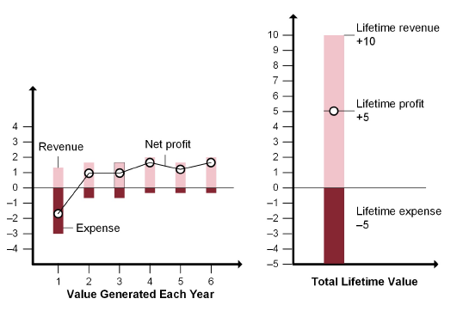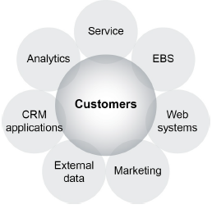

Cost & Revenue from a new customer – Lifecycle

The first component, EBS, is the technological backbone. EBS is the collective name for five critical

applications a company uses:

* Customer database, which contains customer contact details, shipping preferences, and account information
* Transaction maintenance, which enables the electronic entry of sales orders, including those from the internet, and creation of sales history files
* Sales order status and updates
* Sales support data, including pricing, promotion, and inventory information
* Financial details of accounts receivables, interest, collections, and financial analysis

The second component is the web system, which enables customers to use the organization’s website to

order products, peruse product photos and information, generate orders, and participate in online auctions

and even online learning.

Marketing is the heart of customer management. Its critical role is to ensure that customers know about

product, service, and company information that will lead them to making purchases

The CRM application, the fifth component, is actually made up of three elements: operations, collaborative,

and analytical CRM. Operations CRM consists of web portals, email, customer service, ordering, invoicing

and billing, and sales statistics from EBS. Collaborative CRM is used to do forecasting and design

processes. Analytical CRM is focused on the analysis of historical information on customers and how that

information is captured, stored efficiently, and reported.

It is also important to review the metrics that are being used to assess performance. Sometimes

organizations continue to use metrics that have not been revised to be more customer-centric. For example,

a common metric used for call center performance evaluation is the number of win-back customers that have

been convinced to continue as customers. (A win-back customer is one who is terminating or has terminated

their relationship.) However, a better customer-centric metric would include the customer’s value to the

organization in the calculation.

CRM transactional data should be stored in a single database that is integrated and capable of scaling up to

handle a large amount of throughput from CRM operations. This database can also serve for data analysis

and reporting purposes if it is robust enough to handle such demands, or a separate database for reporting

and analysis can be developed, called a customer data warehouse (CDW). The important strategic choice is

between a CDW and a single database. If a CDW is deemed necessary, it should be linked to the

transactional database to receive regular automated batch updates so it can be kept synchronized. If the

choice is to have a single integrated logical database, it can simplify reconciliation but must be robust

enough not to slow down transactional processing tasks. Cloud-based CRM databases are typically used for

both transactional and analysis purposes.

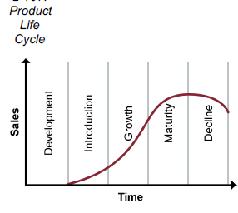

Here are a couple of examples of how technology can be employed to support CRM strategies:

* Customer interaction centers (CICs) are a means of grouping service functions so that the overall

customer experience can be better managed. CICs often use multimedia and other technology tools so

that the customer service representative and the customer can engage in a highly personalized verbal,

texting, or chat interaction. The representative can simultaneously pull up order and account status

information as well as product warranty and maintenance information and account upgrades that are

pertinent to the customer.

* Customer experience management (CEM) technologies have been developed in response to

customers wanting more control over their buying experience and their desire to be treated as

individuals with unique needs and wants. Organizations at the fulcrum of supply chains are using CEM

to generate enhanced customer loyalty and a competitive advantage by listening to the subtle nuances

of customer feedback. These technologies are intended to measure both tangible and intangible

elements, such as customer feelings and expectations, so that the information can be used to create a

superior buying experience.

A **data warehouse** is “a repository of data that has been specially prepared to support decision-making

applications”

One alternative to using a CDW in conjunction with a transactional database is to use a cloud-based

database for either transactional or analysis activities, or for both, as part of a software as a service (SaaS)

or organization-hosted solution.

For organizations able to implement a customer data warehouse, there are many benefits:

**Strategic marketing** For example, the data can be used to identify and implement special offers to loyal customers while enticing prospects with low-cost introductory offers.

**New product development.** Data on customer needs provide valuable input into product design and development decisions.

**Channel management.** Analysis of data on channels may indicate, for example, that moving certain customer segments to lower-cost channels will require incentives.

**Sales productivity.** Human and technology resources can be allocated according to customers’ channel preferences and purchasing patterns to increase sales productivity.

**One-to-one marketing.** The ability to customize programs and create a one-to-one marketing approach cannot be achieved without a CDW.

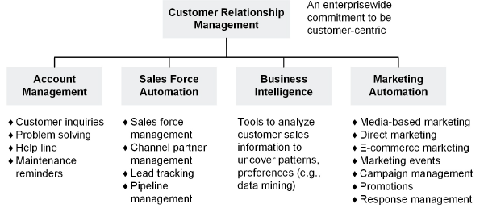

Sales force automation

Sales force automation (SFA) is the core functionality of CRM technology because it collects customer data

from transactions, customer service call centers, and marketing for use in customer acquisition and retention

activities.

Marketing automation

Marketing automation employs software applications to search, compile, and use customer databases to

target customers and then generate a marketing campaign using mass media, direct marketing, the web,

telephone, and other types of technology tools to reach customers. This is known as campaign management

or enterprise marketing automation (EMA).

A problem with TCO in a situation involving outsourcing is that too often companies look at the obvious—purchase price, transportation costs, duty costs associated with doing business on a letter of credit, etc.—but ignore the additional lead time and the associated carrying costs that go along with it. Longer lead times typically involve more inventory in the supply chain, and the carrying cost of that additional inventory needs to be included in the TCO analysis.

**Cost of goods sold**

Lowering the total cost of goods sold (COGS) is of strategic importance to a company. Such costs exert a

strong amount of leverage over profits. A dollar decrease in COGS will be reflected as a dollar increase in

gross margin. A dollar increase of sales has to be offset by COGS, and only the net will be added to the

gross margin. Therefore, reducing the costs of materials, labor, or overhead through efficient supply

management is more effective.

Social Accountability 8000 (SA8000) is an international standard for social accountability that cuts across

multiple industries. SA8000 sets basic standards for child labor, forced labor, health and safety, freedom of association and the right to collective bargaining, discrimination, disciplinary practices, working hours, compensation, and management systems.

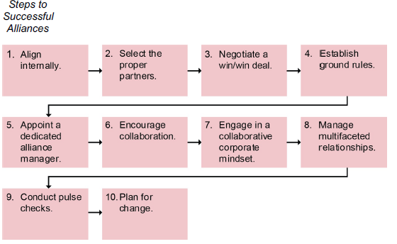

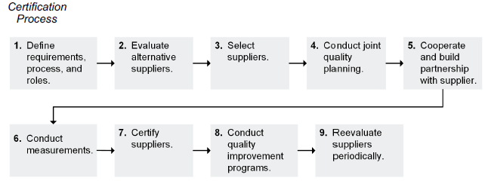

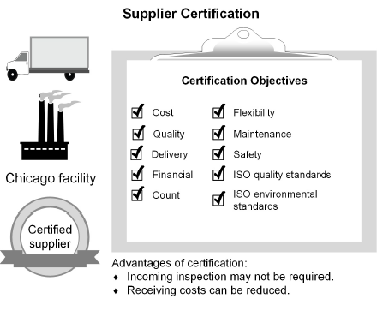

**strategic alliance** is a relationship formed by two or more organizations that share information (proprietary), participate in joint investments, and develop linked and common processes to increase the performance of both

companies.

A **joint venture (JV)** is “an agreement between two or more firms to risk equity capital to attempt a specific business objective”

In addition to the measures already mentioned, supplier performance rating systems can incorporate data for

continuous rating of suppliers from various sources:

**Conformation rates.** Data from each inspection or test should be documented in the system. The

data should include part number, lot size, number of parts accepted or rejected, reason for any

rejections, and the quality disposition.

**Number of floor failure events.** If a supplier-caused discrepancy is found after a part is shipped to

stores or has been installed in an assembly, the organization needs to adjust the performance index

accordingly. The performance index is the relationship of nonconforming costs to purchased costs.

**Levels or amounts of conditionally accepted materials.** These are materials that do not conform to

specifications but are accepted through the material review process.

**Time line performance.** The system tracks the difference between purchase order schedule and

actual receipt dates and identifies undelivered and past-due items and unauthorized early deliveries.

**Controlling errors**

Controlling errors in the supply chain is critical in the overall process of preventing future problems. To do

this, some organizations are implementing online compliance scanning and labeling control systems with

suppliers. These controls prevent suppliers from printing out package labels and shipping goods unless they

comply with the purchase order (PO) or release order rules.

Although each customer/supplier may specify the rules according to their supply contract, examples of these

rules include

“Do not ship unless it is included in the most recent version of PO release.”

“Do not ship +/– days outside of delivery request date.”

“Do not ship +/– amount outside of PO.”

“Do not ship +/– amount outside of PO total.”

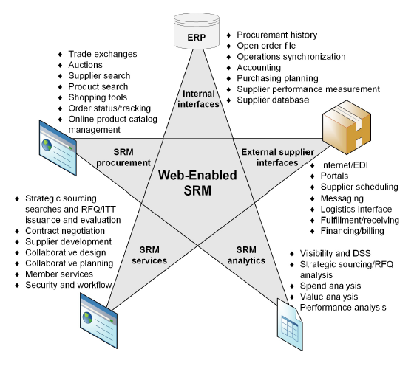

SRM analytics

Analytical technology allows the purchasing and supply chain management group to solve issues related to

the management of materials, information, and finances in the supply chain through the following functions:

**Visibility and decision support systems (DSS).** An analytical SRM solution helps facilitate the

gathering, cleansing, and presentation of procurement information to allow organizations the visibility

they need to support their business decisions. DSS analytical systems assist with optimizing suppliers,

material quality, etc.

**Strategic sourcing/RFQ analysis.** Purchasing and supply management have the information they

need to negotiate the best contracts and support corporate goals.

**Spend analysis.** This strategic application allows the organization to identify who they are buying

from, what they are purchasing from each supplier, and when and how it was purchased. These

comparative data can assist in sourcing and developing strategic relationships and consolidating

purchasing.

**Value analysis.** This analysis finds the purchasing, financing, and delivery processes or activities that

are value-added and seeks to eliminate what is non-value-added. For example, the analysis could

recommend substitution strategies rather than paying expediting charges for a particular material, or it

could recommend substituting a less expensive good or service when the price for quality received is

too high.

**Performance analysis.** Using the analytical approach enables the organization to measure its

procurement performance in terms of cost savings, quality, delivery, price, and overall effectiveness.

The analysis can monitor entire procurement programs, individual suppliers, and contract

effectiveness.

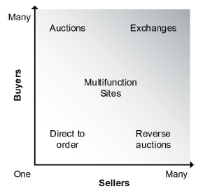

**Horizontal marketplace:** An online marketplace used by buyers and sellers from multiple industries.

This marketplace lowers prices by lowering transaction costs.

**Vertical marketplace:** An online marketplace connecting buyers and sellers within the same industry. It

enables lower prices by lowering transaction costs.

**Exchange ownership models**

B2B marketplace ownership models include the following:

**Independent public trade exchange (ITX) or public marketplace.** These are public sites often used

for indirect materials and commodity purchases where price is the primary factor and where any buyers

and sellers for a particular market meet to gain access to a wider market and find the best deals.

**Private trade exchange (PTX) or private marketplace.**

trade exchange[s] hosted by a single company to facilitate collaborative e-commerce with its

trading partners. As opposed to public e-marketplaces, a private exchange provides the host

company with control over many factors, including who may participate (and in what manner, how

participants may be connected, and what contents should be presented, and to whom). The

ultimate goal might be to improve supply chain efficiencies and responsiveness through improved

visibility and collaboration, advanced integration platforms, and customization capabilities.

Trading may occur between members or only with the owner. PTXs are formed by market-dominant

companies. Most private exchanges are members-only sites, but they do not usually charge fees and

do not force suppliers to compete on price alone. PTXs have been developed by Volkswagen AG and

BMW AG in the automotive industry and by utilities such as the Tennessee Valley Authority and the

Kansas City Power & Light Company.

**Consortia trade exchange (CTX) or consortia-based marketplace.**

an online marketplace, usually owned by a third party, that allows members to trade with each

other. This site lowers members’ search costs and enables lower prices for the buyer.

CTXs are open or member-based sites formed by a consortium of companies, generally within the

same industry. These some-to-many sites are semipublic, in that all members are allowed to trade with

one another and price is often a major factor in purchases. There is a strong focus on finding new

suppliers on these sites. Excess inventory and capacity is frequently traded in a clearinghouse. Ford

Motor Company, General Motors Corporation, and DaimlerChrysler AG formed a consortium-based

exchange, Covisint, in 2000, which was later joined by Renault Nissan and Peugeot Citroen.

(Volkswagen and BMW rejected membership and opted to form private exchanges instead.)

**Virtual trading exchange.** A virtual trading exchange is “an online trading exchange that enables both

information integration and collaboration between multiple trading partners” (*APICS Dictionary,* 16th

edition).

**Supplier co-location**

Supplier co-location is a term often used to describe the practice of locating a supplier or multiple suppliers

within a single location. Consider the following examples.

**Example:** An auto manufacturer invites multiple suppliers into a production plant. The suppliers put

inventory and staff on site so that each one can perform an operation on vehicles as they move along

the production line. In return, the manufacturer provides the suppliers with free space, shelving, office

equipment, and telecommunications.

**Example:** In the airline industry, all alliance partners operate in the terminal of the dominant carrier at an

international airport to facilitate partner connections and product offerings. They offer combined checkin,

member lounges, and ground services.

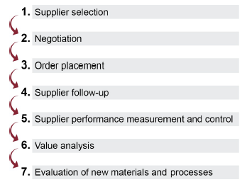

**Annualized contract:** A negotiated agreement with a supplier for one year that sets pricing, helps ensure a continuous supply of material, and provides the supplier with estimated future requirements.

**Bilateral contract:** An agreement wherein each party makes a promise to the other party.

**Contracts for the international sale of goods (CISG):** Governs the sale of goods in the international environment. They enable exporters to avoid choice-of-law issues.

**Trading partner agreement:** A contract between trading partners that describes all facets of their business together. This is a legal and binding agreement suitable for legal purposes as well as standard working agreements.

**Cost-based contract:** A type of purchasing contract where the price of goods or services is tied to the

cost of key inputs or other economic factors, such as interest rates.

**Cost-plus contract:** A pricing method where the buyer agrees to pay the seller all the acceptable costs

of the product or service up to a maximum cost plus a fixed fee.

**Cost-plus-fixed-fee contract:** A contract in which the seller is paid for costs specified as allowable in

the contract plus a stipulated fixed fee.

**Cost-plus-incentive-fee contract:** A contract in which the seller is paid for costs specified as allowable

in the contract plus a profit provided certain provisions are met.

**Firm fixed-price contract:** A contract in which the seller is paid a set price without regard to costs.

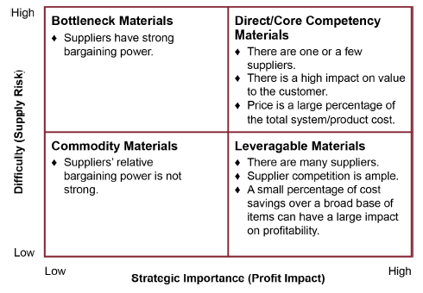

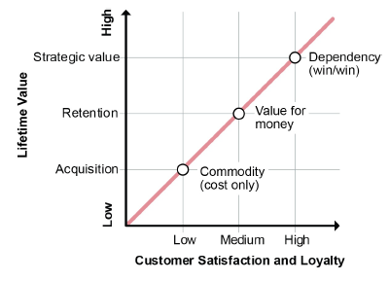

if customer satisfaction and loyalty can be increased, the nature of that relationship will evolve past mere attention to price, to a growing recognition of the product’s or service’s value, and then to a dependency on the product or service that signals the creation of a win/win relationship between customer and business.

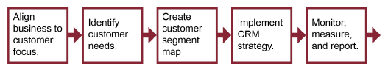

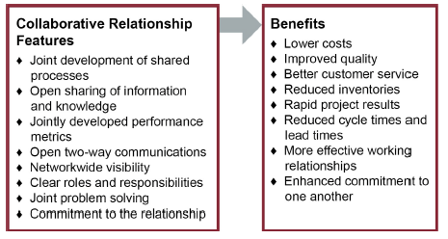

Reverse logistics can occur not only as customers are returning products that were purchased but also as

retailers or distributors return products that failed to sell (e.g., if there are contractual agreements to take

back unsold inventory for some amount of refund or rebate on future purchases) or were defective. Similarly,

manufacturers might return defective or excess products to suppliers.

**Cost avoidance.** A primary purpose of reverse logistics for many organizations is to mitigate loss from

returned items. A return is a reduction in sales revenue. Traditional brick-and-mortar retailers

experience returns in the range of 8 to 10 percent, while online retailers have it even worse, with 20 to

30 percent of products being returned.

Returned items that are unused and fully functional may or may not be able to be marketed as new, depending on regulatory requirements for the industry, and may need new packaging if they can be resold as new.

**Savings in the aftermarket.** Returned products can be “mined” for scarce materials—many of which should definitely be kept out of landfills. Products can be repaired for continued use, refurbished for resale, or disassembled for their usable components.

**Competitive edge.** Consumers can be wooed and won with products that promise good service. For

example, if customers have easy and free return experiences, they are far more likely to become loyal

and profitable.

**Consumer and shareholder pressure.** Consumer groups have learned to make themselves heard

through direct action and lobbying. As part of this movement, shareholder groups bring resolutions to

corporate annual meetings proposing various “green” or consumer-oriented policies. Sometimes these

pressures result in changed corporate policies when companies sense an opportunity to turn such

sentiments into customer loyalty and sales.

**Growing market for environmentally safe products.**

**Safety and environmental awareness and regulations.**

The EU has made a strong commitment to waste reduction. For example, Germany requires that all German businesses must accept returns of their packaging. In the Netherlands, a disposal fee is charged when many kinds of new products—appliances, TVs, cars—are purchased. These funds are used to disassemble products

at the end of their life.

**Warranty strategy and design**

A product’s warranty period creates a liability for an organization since defective products will need to be

replaced for no charge during this period. Warranties are offered to promote sales by providing peace of

mind for buyers, so both the costs and the benefits of these programs should be estimated. The benefit is

the increase in sales from the warranty. The costs are the cost of returns that need to be charged off as well

as the financial uncertainty of how many returns there will be. (It could be as much as all products sold, for

example, in a recall situation.)

A complication arises when the warranty periods on supplier components differ from the warranty period on

the final product offered to customers. A repair on a product warranty may require replacing parts that are

not under warranty for the manufacturer, meaning that this cost cannot be passed on to the supplier. This

can create a hidden liability that is difficult to calculate when determining the costs of reverse logistics.

For B2B returns, a lot-size return policy might make sense. This involves requiring corporate customers to

hold returns until full truckload quantities can be sent, to make transportation more economical. In a B2C

(business-to-consumer) example, Dell allows products to be returned only after the customer speaks directly

with a live customer service representative. While there is a cost for this direct support from what they call

“gatekeepers,” the representative is given the opportunity to provide instruction on how to properly set up the

device, up-sell support devices, or otherwise talk the customer out of the return. This investment is costeffective

because it results in a 5 percent level of returns (as opposed to a 10 percent return rate for its

former competitor CompUSA, which eventually went out of business for this and other reasons).

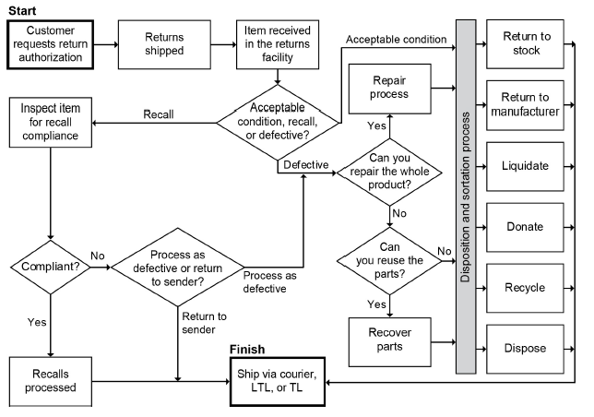

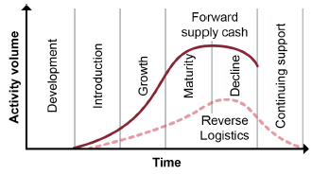

However, the reverse logistics curve is shifted forward, since returns don’t start until products are shipped, and it is smaller, because only a percentage of products will be returned.

Product introductions

Even in the initial phase of a product introduction, reverse logistics comes into play:

* Customer service has to be prepared for early returns of the new product, since defects and

disappointments are more likely during ramp-up than during later stages of a product’s life. High-quality

customer service can prevent the worst effects of early product failures. (There’s a role for sales and

marketing here, too.) A flood of early returns can cause serious logistical problems—not to mention the

negative impact on reputation and customer loyalty—if the reverse supply chain hasn’t been set up to

handle such an unpleasant surprise.

* If early product returns are heavy, design engineers need to be prepared to make rapid improvements

in the product.

* The service department needs to be in place at this time, as does an inventory of replacement parts.

Maturity

Reverse logistics events continue into product maturity:

* Returns are a high-volume operation in some industries—up to 10 percent for computers.
* Receiving areas need to be designed to accommodate operations required in handling returns, such as

repackaging and inspections.

* Packaging for returns needs to be considered along with packaging for forward shipping. For example,

HP laser cartridges are delivered to consumers in a box with simple instructions for how to repackage

the used cartridge in the same box and give it, free of charge, to any UPS driver or facility for shipping

back to the manufacturer. This reverse network, complete with training for UPS, had to be in place and

ready to receive cartridges when the first products were shipped to retailers.

Decline, return, and continuing support

The reverse supply chain should be designed to anticipate problems that will arise after the product ceases

to be useful. Product continues to be shipped—in both directions—because of returns, recalls, etc. The

following are significant concerns relevant to product decline, return, and continuing support:

* Preparation should be made for any environmental and legal exposures. This is especially true with

hazardous materials—such as lead used in jewelry—that are subject to extra regulations locally,

nationally, and internationally. Hazardous materials are covered elsewhere.

* Nonhazardous materials may also be subject to extra regulations. For example, one beer manufacturer

requires its distributors to have a permit to dump recalled beer. The glass and cardboard packaging

also have to be recycled at the same time.

* Final disposal needs to be documented and the records kept for a period of years.
* Packaging as well as products should be designed for reuse or made biodegradable.
* Parts, customer service support, and other services may need to be provided for a certain period

following the discontinuation of a product.

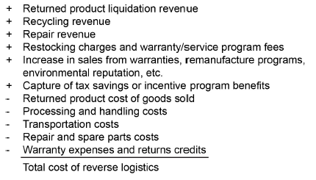

Waste is defined as:

1) Any activity that does not add value to the good or service in the eyes of the consumer

2) A byproduct of a process or task with unique characteristics requiring special management control. Waste

production can usually be planned and somewhat controlled. Scrap is typically not planned and may

result from the same production run as waste.

**total waste management (TWM)** is a methodology that enables finding solutions to waste issues while keeping in mind financial elements and the business case.

**waste hierarchy** is a tool that ranks waste management options according to what is most environmentally sound. It gives top priority to preventing waste in the first place, and can be applied to various applications.

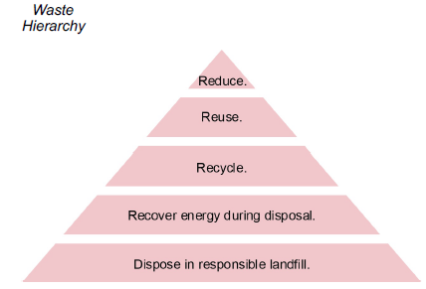

**40/30/30 rule** is a rule that identifies the sources of scrap, rework, and waste as 40 percent product design, 30 percent

manufacturing processing, and 30 percent from suppliers.

While this is a rule of thumb and could differ depending on the product, it shows how up-front work during the

design of products and manufacturing processes and supplier selection will have big payoffs in waste reduction, which will lead to efficiency improvements and thus to higher profitability.

Reuse products or components.

Potential reuse of products or parts of products is considered second in importance to resource

conservation. The payoff is a reduction of the costs involved in purchasing, transportation, and disposal. This

can be accomplished in several ways.

* Resell returned products that pass quality control, repackaging and relocating products as needed (to

new selling locations, including resellers).

* Donate excess inventory to charities as appropriate and allowed, which may provide a tax benefit. (For

example, Habitat for Humanity, a charity that builds homes, is a common recipient of excess building

materials.)

* Remanufacture products to like-new condition by replacing worn parts with new parts and sell at a

discount or as part of a trade-in program. This is especially appropriate for big-ticket items; for

example, Caterpillar has a program like this for industrial equipment.

* Sell by-products to organizations that can use them as raw materials (discussed in detail elsewhere).
* Design products so materials and components can be more easily separated for reuse. This is called

design for disassembly and recycling.

Recycle materials.

After resource conservation and reuse, recycling is the third most important aftermarket principle. The

concept of recycling isn’t easily separable from the concept of reuse, and, in fact, the two can be combined.

When containers (bottles, barrels, totes, drums, etc.) are cleaned, sterilized, and filled again, they are

reused. When containers are reprocessed into other products, such as landscaping materials, they have

been recycled. When a product is broken down into components, some parts may be reused, some recycled,

and some sent to the landfill. Recycling reduces disposal costs; reuse can reduce purchasing and

transportation costs as well.

Recycling requirements can also change. For example, while lead acid batteries from cars have a 99 percent

recycle rate, the new Lithium-ion batteries used in electric cars (such as Tesla) have not yet developed a

recycling stream. In ten years or so, when these electric cars reach their end of life, this issue will become

critical. Advocating now for solutions at the federal levels of government would allow this process to be

consistent.

a **responsible landfill** is landfill operations designed to turn waste into recoverable resources, minimize the amount of space consumed, and maximize the operational life of the landfill.

**waste exchange** is:

1) Arrangement in which companies exchange their wastes for the benefit of both parties

2) An exchange service of valuable information between generators and potential users of industrial and

commercial wastes, whereby a beneficial use rather than disposal is the end result. This service

identifies both the producers and potential markets for by-products, surpluses, unspent materials and

other forms of solid waste that is no longer needed.

One organization’s by-product or other type of waste may be another organization’s raw material. Long ago,

tanners would collect chamber pots around the community each morning to use when tanning leather, which

provided a side benefit of reducing the amount of human waste flowing through the streets. Today, many

organizations seek to sell their by-products or other waste at market rates, both generating revenue and

reducing disposal costs. In the waste hierarchy, this would qualify as reuse of materials, so it is quite high on

the scale of effective responses.

The second part of the definition of waste exchange reveals that organized information exchanges are the

key to finding or creating a market for certain waste products. Tyson used to discard its chicken feet until it

discovered that there was a huge demand for them in Asia. Now it ships these overseas. In fact, every part

of the chicken gets used for something. Even the feathers are baked and become a powder additive to pet

food.

**Globally Harmonized System of Classification and Labeling of Chemicals (GHS)** is

an international standard, created by the United Nations Economic Commission for Europe (UNECE),

for classifying chemicals according to their health, physical and environmental hazards. The system

defines and classifies the hazards of chemical products, and communicates health and safety

information on labels and material safety data sheets.

Strict waste regulations exist in the European Union and in many other places. Let’s look at two regulations

used in the EU as examples.

* The Wastes of Electric and Electronic Equipment (WEEE) legislation in the European Union places the

burden of disposing of computers, monitors, televisions, printers, and other devices and peripherals on

the manufacturers. Consumers can deliver the devices to the manufacturer, and the manufacturer

cannot charge a fee. The manufacturer is required to properly identify and dispose of the materials.

This legislation provides incentives to rely more on the higher activities in the waste hierarchy, for

example, recycling before responsible landfill. A large number of U.S. states have similar “e-waste”

legislation.

* The EU’s Restriction on Hazardous Substances (RoHS) Directive is aimed at the apex of the waste

hierarchy—reduce—and the product development life cycle stage. It limits the amounts of lead,

cadmium, mercury, hexavalent chromium, polybrominated biphenyl, and polybrominated diphenyl ether

that new electrical and electric equipment can contain for it to be sold within the EU from any source.